Hollis J. Goff

September 12, 1929 – February 17, 2015

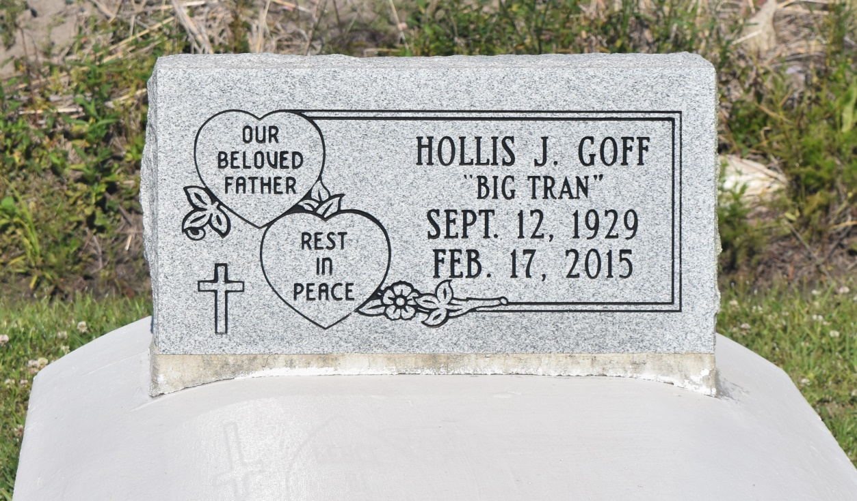

Hollis J. Goff at the age of 85 yrs. departed this life on Tuesday, February 17, 2015 at Thibodaux Medical Center with his daughter, granddaughter, son in law, other friends and family at his bedside. He is survived by his only loving and devoted daughter Linda (Lionel) DeSouza, only granddaughter Eumekia Jackson, one beloved sister Betty Goff, god child Donna Scott. Devoted care takers Melissa Wiggins and Cheryl Howard of Healing Hands Home Health Care, Inc. Brother of the late Annaretha, Helen, Russell, Sidney, Lydia, Lucretia, Beaulah, Wilhemina, Margret, Irvin and Rudolph. Also survived by a host of nieces, nephews other relatives and friends. A native of Edgard, resident of Wallace, La.

Relatives and friends also Priest and Parishioners of St. John the Baptist Catholic Church, Woodville Baptist Church and all neighboring churches, the staff of Healing Hands Home Health Care, Thibodaux Medical Center, Masters Medical Equipment, Alumni Medical Sleep management, employees of UTZ Potato Chips are invited to attend the home going services on Saturday, February 21, 2015 at 10:00 am at St. John the Baptist Catholic Church, 2349 Hwy 18, Edgard, La., Father Robuskian Morgia. Interment in Woodville Cemetery in Wallace, La. Visitation will be at the above church from 8:30 am until service time. Bardell's Mortuary of Mt. Airy, La., in charge. Information: 985-535-6837.

**Downloaded from legacy.com on 4/28/2018**