Claude Gordon Jr.

March 28, 1943 – January 12, 2017

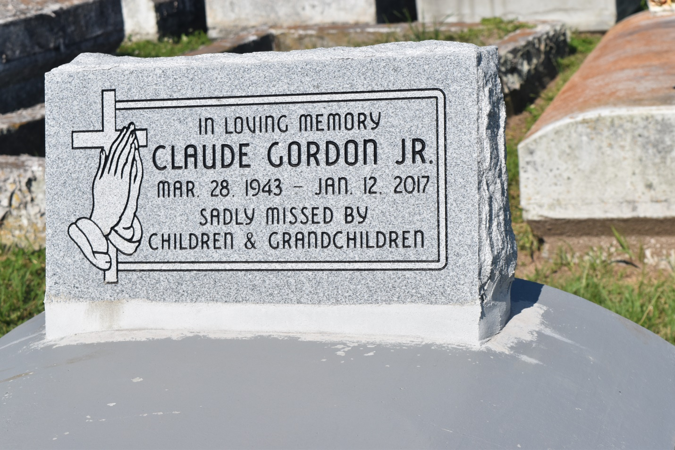

Claude (Mann) Gordon Jr. peacefully entered into eternal rest on Thursday January 12, 2017 at the age of 73. A native of Edgard and a resident of Wallace, La.; son of the late Louisa Thomas Gordon and Claude Gordon Sr. He leaves to cherish his memories his lovely wife, Willomease Holland Gordon, his children Andriea (Wilbert) Thomas, RhonJean (Edward) Davis, Claude (Cheryl) Gordon lll, Tiffany (Melvin) Carr, Marlon Smith Sr., Leslie (Jonathan) Cryer, Jarius Warren. Stepfather of Cory, Albert Jr. Kieron Batiste, Regina Leno. Siblings Larry (Debra)Gordon, Felicia (Michael) Williams, Norman (Reggie) Gordon, Clarence Gordon, Gail (Albert) Favorite, Ferdinand (Mary) Gordon, Robin (Brent) Wilson, Jacqueline Harry, Betty Nicholson, Melissa (Dyrell) Washington, and Jacqueline Campbell. Survived by 13 grandchildren, 7 great- grandchildren, a host of nieces, nephews, godchildren, relatives and friends.

Relatives and friends of the family, Rev. Vernon Alexander, Sr. along with officers, and members of Greater New St. Peter B.C Edgard, La. are invited to attend a celebration of life on Saturday January 21, 2017 at 11:00 am at New Zion Christian Center 216 West Main St. Gramercy, La., Rev. Dean Mitchell pastor; Min. Cory Batiste, officiating. Visitation from 9:00 am until service time. Interment Woodville Cemetery, Wallace, La. Arrangements of his final care entrusted to Treasures of Life Center for Life Funeral Services, 315 E. Airline Hwy. Gramercy, La. "WHEN SOMEONE YOU LOVE BECOMES A MEMORY THAT MEMORY BECOMES A TREASURE!"

**Published in The Times-Picayune (LA) on Jan. 20, 2017**