Evelyn (Gaudet) Gordon

July 15, 1930 – December 24, 2010

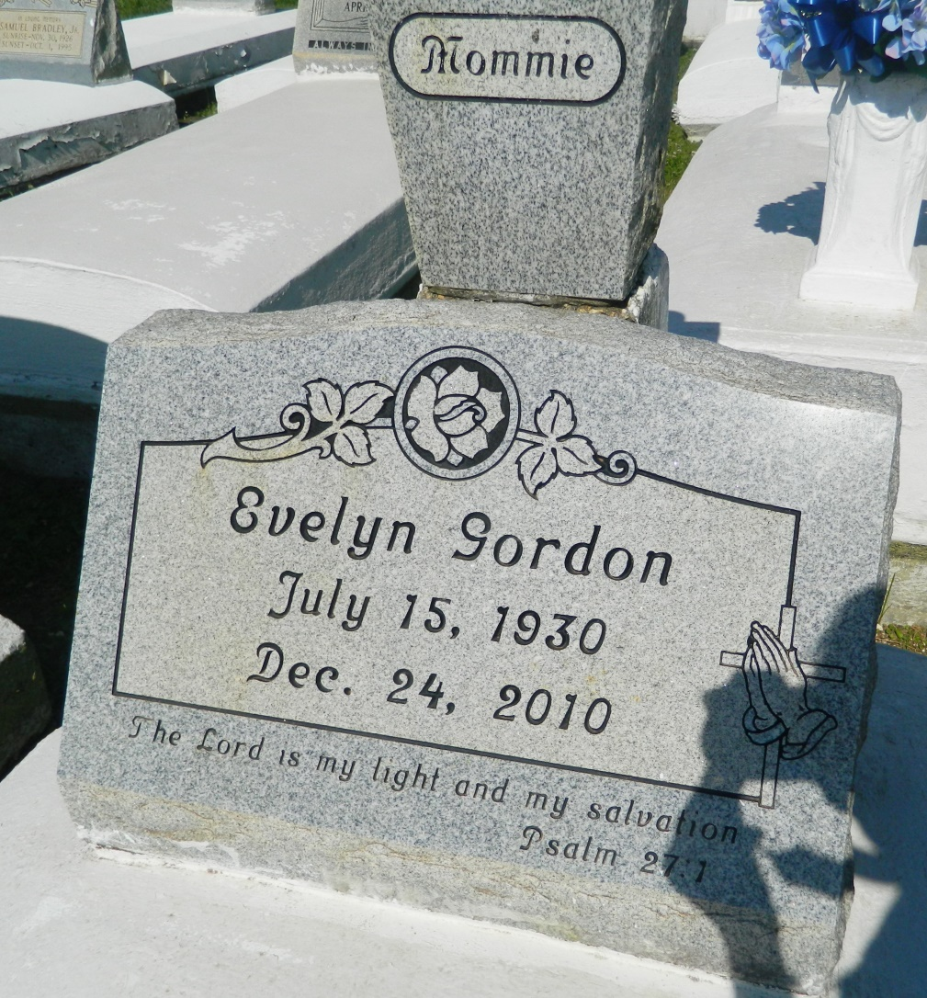

Evelyn (Mommie) Goudia Gordon, on Friday, December 24, 2010 at 9:00 a.m. at her residence in Wallace, Louisiana, entered into eternal rest at the age of 80. She was born July 15, 1930. She was educated in Orleans Parish School System. She was predeceased in death by her parents, Emile Gaudet, Sr., and Cora Peters Gaudet, her husband, Samuel Gordon, Sr., grandson, Gary Gaudia, granddaughters, Kendra Stennet and Arye Lewis, stepson, Isaac Gordon, 4 brothers, Emile Gaudet, Sr., Royal Gaudet and Russell Gaudet, 5 sisters, Verna Bush, Elizabeth Burgess, Audrey Scott, Augustine Turnage, Almateen Goudia. She leaves to cherish her memories: her children: Paulette (Frederick) Joseph, Gerald (Judith) Gaudia Sr., Emelda (Donald) Saul, and Samuel Gordon, Jr., of Wallace, Louisiana. Nelson (fiancée-Debra Howard), Sherman (Kathleen) Gordon, Kevin Michael (Janel) Gordon, Sr., Darrell (Lisa) Gordon, Shanna (Kirk Sr.) August, Louanda (Gregory) Scott, Lisa Roussell, Sabrina (Brian) Lewis, Jessica (James) Wright, Renata Adams, 1 brother, Charles Gaudia, 3 sisters-in-law, Clara Gaudet, Luberta Clofer and Leah Stewart, 34 grandchildren, 30 great-grandchildren, 1 godchild, Patricia Gordon, nieces, nephews, cousins, other relatives and friends.  
  
Relatives and friends are invited to attend the funeral services held on Thursday, December 30, 2010 at 11:00 am; the First Community Antioch Baptist Church, 10860 Hwy 3125, Lutcher, Louisiana, officiating, Rev. Ferdinand Gaines. Interment will be held at Woodville Baptist Church. Visitation begins at 9:00 a.m. until service. The Baloney Funeral Home, LLC is in charge of arrangements. Guests may sign the register at [www.baloneyfuneralhome.com](http://www.baloneyfuneralhome.com/).

**Times-Picayune, The (New Orleans, LA) - Wednesday, December 29, 2010**

**Contributed by Jane Edson**