Ruby Ann Grant

August 2, 1939 – March 15, 2010

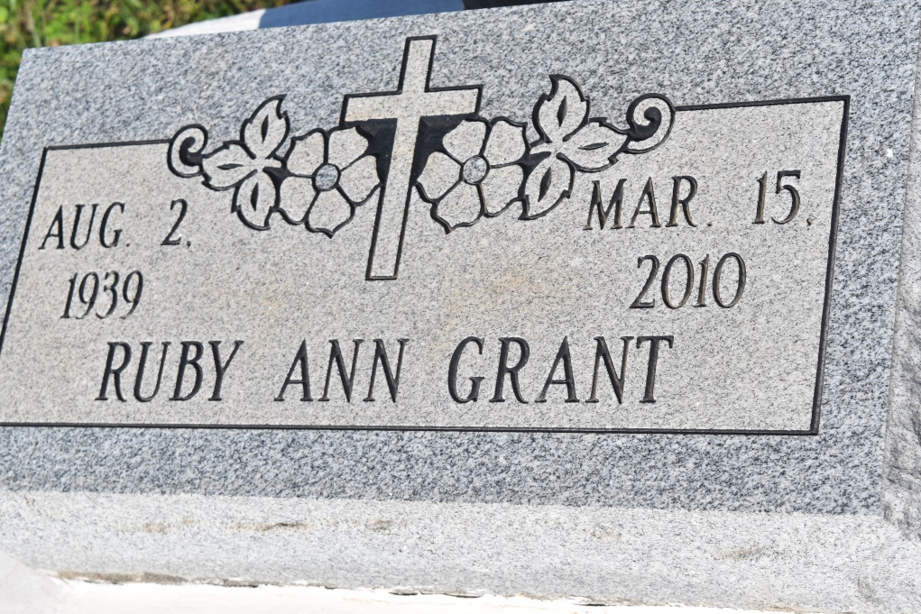

Ruby Ann Grant, of Lutcher, LA, on Monday, March 15, 2010 at 7:30 am. at Touro Hospital. Daughter of the late Rev. Wilkerson Grant and Wilberine Mary Armont. Sister of Augustine Davis and the late Ethel G. Anderson. Sister of Augustine Davis, the late Ethel G. Anderson and Alfred Grant, Sr. Foster sister of Jenny Cooper, Rosetta Lirette, Dorothy Elder, Diane Wilson, Geneva Lucas and the late Beulah Lirette. Devoted aunt of Charlotte Ann Grant. Devoted godmother of Michelle Armont. Also survived by sister-in-law, Carolyn Grant; and a host of other nieces, nephews, cousins and friends. A native and resident of Lutcher, LA. Age 70 years.  
  
Relatives and friends of the family, also pastors, officers and members of Greater Woodville B.C., neighboring churches, Central Union Missionary Bapt. Assoc., employees of LSU Health Care Network, St. James Parish School Board, and Touro Hospital are invited to attend a Homegoing Celebration on Saturday, March 20, 2010 at 11:00 a.m. from the Greater Woodville B.C., 193 West 9th St., Wallace, LA. Rev. Marc Nelson, officiating. Interment Woodville Cemetery. Visitation at the Church after 9:00 a.m. Final viewing before services.  
  
The Baloney Funeral Home, LLC, 399 Earl Baloney Dr., Garyville, LA 70051. Information: (985) 535-2540 In Charge of Arrangements

Times-Picayune, The (New Orleans, LA) - Friday, March 19, 2010

Contributed by Jane Edson