Mildred (Ross) Hall

January 1, 1937 – November 6, 2010

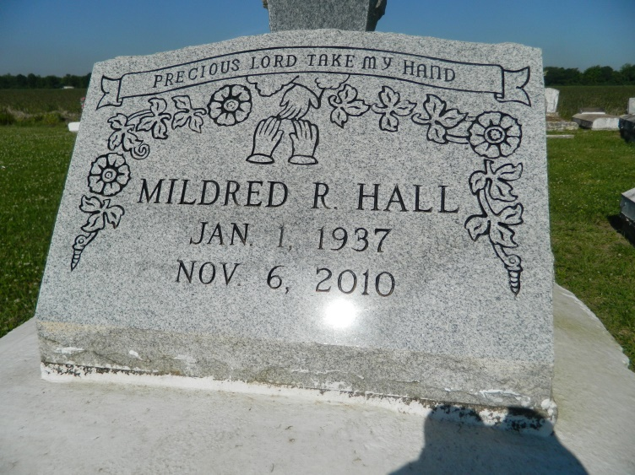

Mildred "Mee Mee" R. Hall passed away on Saturday, November 6, 2010 at Ocshner Baptist Hospital with her family by her side. She was 73 years of age. She was the beloved wife of Jessie H. Hall, Sr. for 57 years and the loving mother of Jessie Hall, Jr., Charlotte Hall, and Marcelin Brisco. She was the grandmother of 7, the great-grand-mother of 8, the sister of 9 siblings. She is also survived by a host of loving nieces and nephews, cousins, other relatives, and friends. She is preceded in death by her father and mother Walter Ross and Daisy Ross Poche and one grandchild Jessie H. Hall III.  
  
Relatives and friends are invited to attend a Funeral Service at Second Free Mission Baptist Church, 1228 Burdette Street, New Orleans, LA 70118, on Saturday, November 13, 2010. Visitation begins at 9am until 10am service. Interment will follow in Woodville Cemetery, Wallace, LA.  
  
Arrangements by The Baloney Funeral Home, LLC. Friends may sign the guest book at [www.baloneyfuneralhome.com](http://www.baloneyfuneralhome.com).

**Times-Picayune, The (New Orleans, LA) - Friday, November 12, 2010**

**Contributed by Jane Edson**