Louellia (Johnson) Holly

January 1, 1906 – January 16, 2004

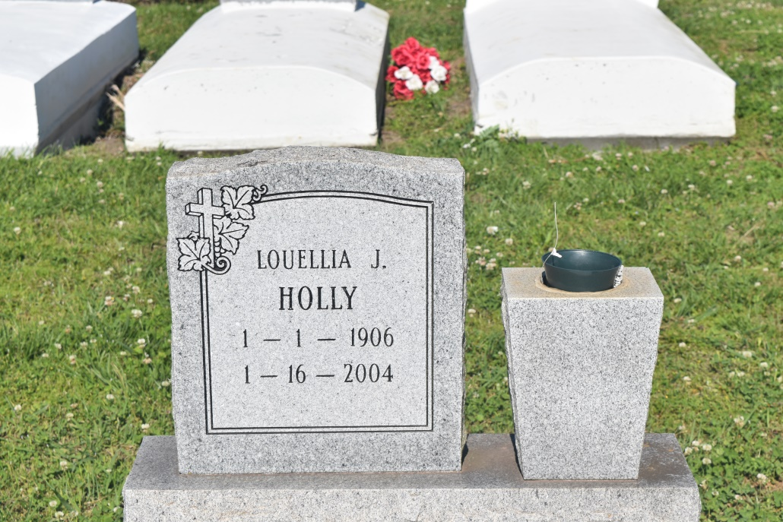

WALLACE - Luella Johnson "Na Name" Holly, 98, a native of Wallace and resident of Jefferson, died Jan.16. She was the wife of the late Stamp Holly, and mother of Alfred Grant.  
  
She is also survived by three grandchildren, six great-grandchildren and two great-great-grandchildren.  
  
Dismissal services were Jan. 20 at Greater Woodville Baptist Church, Wallace, with interment at the church cemetery.

**L'Observateur (La Place, LA) - Tuesday, January 20, 2004**

**Contributed by Jane Edson**