Alfred Jackson, Jr.

September 23, 1916 – January 8, 2016

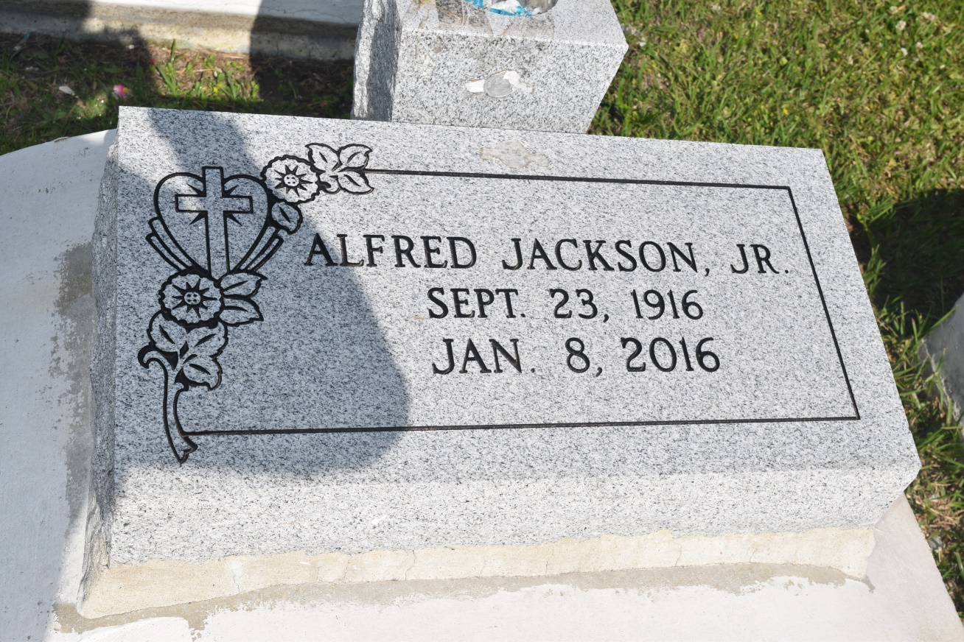

Alfred "Nook" Jackson Jr. at the age of 99 yrs. departed this earthly life on Friday January 8, 2016 at his residence in New Orleans, La. Husband of the Late Theresa Jackson by 1st Marriage and the Late Myrtle Jackson by 2nd Marriage. Beloved father of Milton (Barbara) Jackson Sr., Doris (William) McFadden, and Stella Mae (Jerry) Richardson. Also survived by 12 grandchildren, 26 great-grandchildren, 16 great-great-grandchildren and a host of nieces, nephews, other relatives and friends.

Relatives and friends of the family also Pastors, Officers and Members of The Greater Woodville Baptist Church of Wallace, La and all neighboring churches are invited to attend the home going celebration on Saturday January 16, 2016 at 10:00 am at The Greater Woodville Baptist Church of Wallace, La. Pastor Marc Nelson officiating. Interment in Woodville Cemetery of Wallace, La. Visitation will be at the above name church from 8:00 am until service time. Bardell's Mortuary of Mt. Airy, La. in charge. Information: 985-535-6837.

**Downloaded from legacy.com on 4/28/2018**