Marian Jackson

August 29, 1940 – November 18, 2004

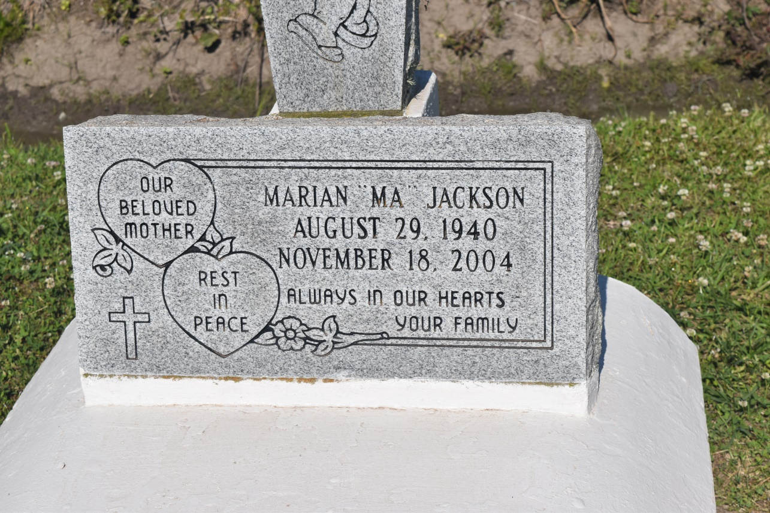

Marian "Ma" Jackson, a homemaker, died Nov. 18 of a heart attack at St. James Parish Hospital. She was 64. She was a lifelong resident of Wallace. She was an usher and member of Greater Woodville Baptist Church. Survivors include a son, Norman Armour Jr. of Vacherie; a daughter, Linda Jackson of Wallace; five brothers, James, Chatman, Terrell and Clarence Jackson Sr., and Isaac Jackson Sr.; a sister, Clara Edwards; and three grandchildren.

A funeral will be Friday at 11 a.m. at Greater Woodville Baptist Church in Wallace. Visitation will begin at 8 a.m. Burial will be in the church cemetery.

Bardell Mortuary is in charge of arrangements.

**Times-Picayune, The (New Orleans, LA) - Thursday, November 25, 2004**

**Contributed by Jane Edson**