Alvin Ernest Jones Jr.

March 6, 1950 – April 1, 2017

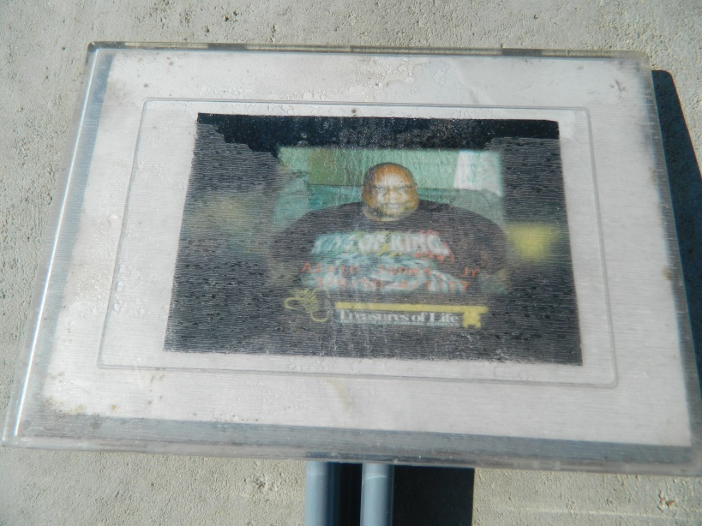 

Alvin Jones Jr. of New Orleans, La. departed this life on Saturday April 1, 2017 at Passages Hospice. Son of the late Alvin and Priscilla Baptiste Jones. Father of Latoria ”Tori”, Nia Imani Jones, Ta’Najee Johnson (Donald), Joseph Izebeizua, Jerron, Frank and Jonathan Tate. Brother of Frederick “Ricky” Jones (Hilda), Dennis Jones and the late Jerome Jones and Jeanette Jones Gaylor. Godfather of Jade Miller. Grandfather of Mckinsey Williams and Darius Smith Jr. Nephew of Shirley Ross. Uncle of Shelita G. Morgan (Jared), Melanie G. Turner (Brian), Frederick Ross (Tanya), Sean, Jerome Gaylor, Jared Morgan, Brian Turner, and the late Kevin McKinsey. Also survived by a host of great and great great nieces, nephews, cousins, other relatives and friends.

A funeral celebration will be held on Thursday April 6, 2017 at 10:00 am from Christian Unity Baptist Church, 1700 Conti St., New Orleans, La., Pastor Dwight Webster officiating. Interment Woodville Cemetery, Wallace, La. Visitation at the church after 9:00 am. Final care entrusted to Treasures of Life Funeral Services 315 E. Airline Hwy. Gramercy, La. “When someone you love becomes a memory that memory becomes a TREASURE”

**Treasures of Life Center online obit (accessed 4/28/2018)**