Jennifer Jones

June 27, 1946 – August 9, 2008

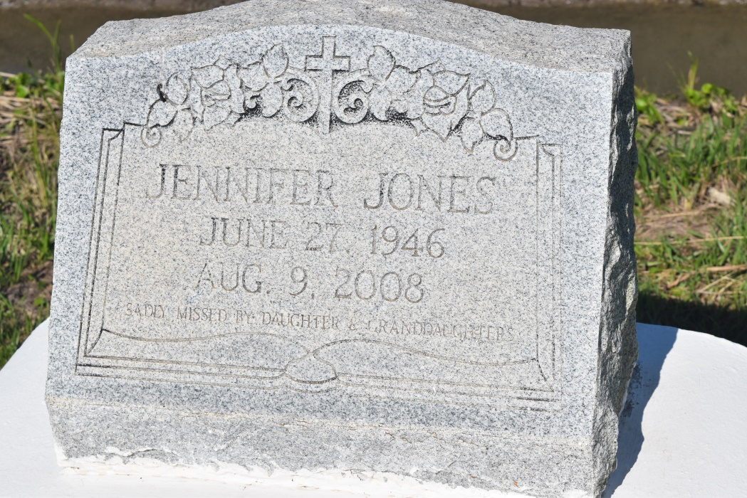

Jennifer Jones, of Wallace, La., age 62, and a former Shrinker at Northrop Gruman (Avondale) departed this life on Saturday, August 9, 2008 at St. James Parish Hospital. Daughter of the late Cecelier Bradley Calvon. Mother of Renee Jones of Wallace, La. Grandmother of Jennifer J. Jones and Jennika J. Jones of Wallace, La., niece of Wilfred Armant and the late Elvira Armant, Anna Mae B. Jackson, Rosemary B. Gordon, Melvin Sr., Samuel Jr., and Nathan Bradley. Godmother of Lendell Brown. Also survived by a host of cousins, other relatives and friends, a native and resident of Wallace, La.  
  
Relatives and friends of the family, also pastors, officers and members of the Greater Woodville B.C. and neighboring churches, Employees of Avondale Shipyard, Terreborne General, Thibodaux Regional Medical Center, Vacherie Dialysis, St. Joseph Medical Clinic, St. John ARC, Nicholls State Univ and East St. John High School are invited to attend the Funeral Services on Thursday, August 14, 2008 at 11:00AM from the Greater Woodville B.C. - Wallace, LA. Rev. Marc Nelson, Officiating. Interment in Woodville Cemetery, Wallace, LA. Visitation at the church after 9:00AM.  
  
The Baloney Funeral Home, LLC, 399 Earl Baloney Dr., Garyville, LA 70051; 985-535-2540   
In Charge of Arrangements.

**Times-Picayune, The (New Orleans, LA) - Wednesday, August 13, 2008**

**Contributed by Jane Edson**