Priscilla Mae (Batiste) Jones

March 19, 1927 – April 15, 2002

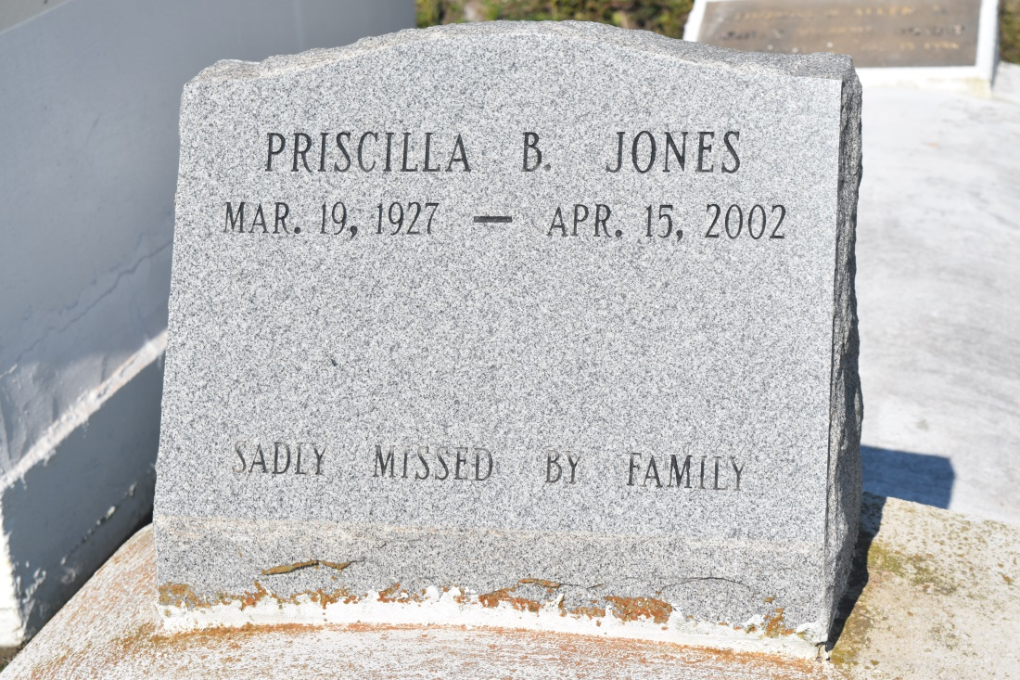

Priscilla Mae Batiste Jones, a retired assistant custodial supervisor for the Orleans Parish school system, died Monday of complications from a stroke at her home. She was 75. Mrs. Jones was born in Wallace and lived in New Orleans for 54 years. Survivors include her husband, Alvin Jones Sr.; three sons, Alvin Jr., Frederick and Dennis Jones; a daughter, Denise Jones; a brother, Calfrey Jones; a sister, Pamela Davenport; eight grandchildren; and 10 great-grandchildren.

A service will be held Saturday at 11 a.m. at the James Chapel Missionary Baptist Church at 4228 Thalia St. in New Orleans. Visitation will begin at 10 a.m. Burial will be in Woodville Missionary Baptist Church cemetery in Wallace. The Baloney Funeral Home is in charge of the arrangements.

**Times-Picayune, The (New Orleans, LA) - Friday, April 19, 2002**

**Contributed by Jane Edson**