Dianne Mae (Favorite) Peterson

April 25, 1952 – June 22, 2018

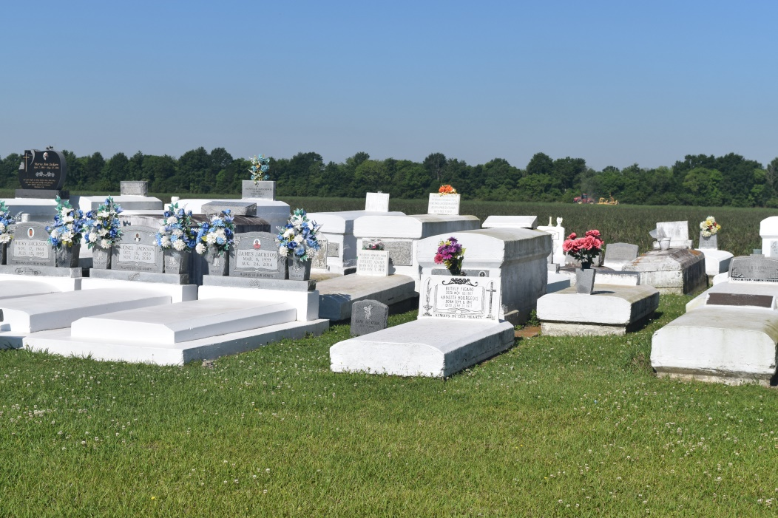

Dianne M. Peterson, of Vacherie, La. on June 22, 2018, God dispatched his angel to her home and freed her from this earthly life to receive her heavenly reward. Born to Leola Populis and the late James Favorite, Sr. on April 25, 1952 in New Orleans, La.

She lived in Slidell, La. for a short period but returned to her roots in St. James Parish where she remained until her passing. She truly lived her life to the fullest. She had a great love for her family and loved spending time with them, especially her children. She worked the last 23 years of her life as a custodian at Oak Alley Plantation House. Dianne accepted Christ early in life and was baptized at Greater Woodville Baptist Church. She united with the New Hope International Family several years ago and was faithful in her service to the Lord until her illness.

Dianne leaves to cherish fond memories her mother, Leola Populis, one son Elston (Clarissa) Peterson of Gramercy, La. 3 daughters, Tammy, Ranada and Tiffany Peterson of Vacherie, La. Sisters, Melinda Gros, Maybelline Burdis, Leola Lebeouf, Kathy F. Glover, Cynthia Pilart, Valerie Favorite, Andrea Mason, Arnell Sentimore, and Donna Green. Brothers Carl Sr., Troy Favorite, Andrew Jasmine, Roger Darensbourg. Grandchildren Essence Peterson, Keshana Bright, Odeyssey Peterson, Aleeyah Lewis, Asia Peterson and Donal Santos. Great grandchildren Za’rone Smith , Rokedrick, Ra’Carri and Ralayah Williby and a host of aunts, uncles, relatives and close friends. She was preceded in death by her father James Favorite Sr., her husband Alphonse Peterson, siblings James Jr., Donald Favorite grandson Carvell Joseph Bright Jr., grandparents Melvina Joseph, Freddie Populis, Sr., and uncle Walter Populis, Sr.

A funeral service will be held on Saturday July 7,2018 at 11:00am from New Hope International Family Worship Center 21490 LA-20 Vacherie, La. Dr. Claudette Aubert officiating. Interment Woodville Cemetery, Wallace, La. Visitation at the church after 9:00am.

Final care entrusted to Treasures of Life Funeral Services 315 E. Airline Hwy. Gramercy, La. 70052.

[www.treasurefunerals.com](http://www.treasurefunerals.com) (accessed 10/7/2018)