Barbara Mae (Farlough) Rogers

June 30, 1947 – October 28, 2009

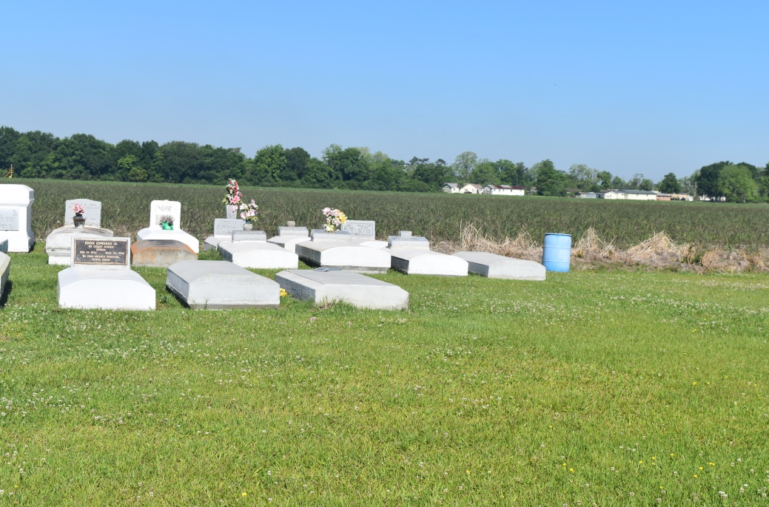

Barbara Mae Farlough-Rogers departed this earthly life and entered into eternal rest on Wednesday, October 28, 2009 in Antioch, CA. Daughter of the late Earl J. Sr. and Sylvia F. Farlough. Beloved wife of Edward Eugene Rogers of Antioch, CA. Loving mother of Damien Keys, Kyles Farlough and Shanice Rogers. Sister of Myrtle F. Victor and Hilton (Faith) Farlough of Reserve, LA, Earline (Richard) Bowser of Lutcher, LA, Hersey Farlough of Mt. Airy, LA, Phylis Williams of Gonzales, LA, Greta Green of Texas and the late Milton and Earl Farlough Jr. Also survived by 2 grandchildren, nieces, nephews, other relatives and friends. A native of Mt. Airy, LA and a resident of Antioch, CA.  
  
Relatives and friends of the family, also Pastors, Officers and Members of St. John Missionary Baptist Church of Mt. Airy, LA and all neighboring churches are invited to attend the Funeral Services on Tuesday, November 10, 2009 at 11:00 AM at St. John Missionary Baptist Church, 287 Daffodil St., Mt. Airy, LA. Rev. Gary Bolden officiating. Interment in Woodville Baptist Church Cemetery of Wallace, LA. Visitation will be at the above named church from 9:00 AM until Service time.  
  
Bardell's Mortuary of Mt. Airy, LA in charge. Information: 985-535-6837

**Times-Picayune, The (New Orleans, LA) - Monday, November 9, 2009**

**Contributed by Jane Edson**