Ethel Mae (Jackson) Young

July 17, 1947 – April 20, 2016

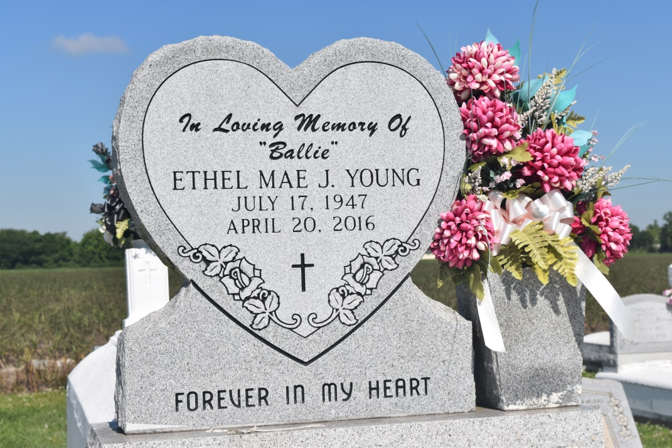

Sister Ethel departed this earthly life at age 68 and entered into her eternal resting home on April 20, 2016, at Ochsner (St. Charles Parish Campus) Hospital at 12:58 p.m. Sister Young accepted the Lord as a young child and served as a faithful Usher. Loving wife of the late Edward Young. She leaves to treasure her memories a loving daughter, Rosalyn Young, one grandson Darien, a devoted sister, Marie Green (George), two brothers, Bienville Jackson, Jr., Albert Jackson (Olivia) and two brothers in law, Sidney and Lloyd Young, and a devoted friend and driver Stafford Jacob. She is preceded in death by her parents Bienville and Annie B. Jackson, Sr., and one brother Henry Clay. Survived by a host of nieces, nephews, relatives and friends.

A celebration of life will be held on Saturday, April 30, 2016, for 1:30 p.m. at First Community Antioch Baptist Church, 10860 Hwy. 3125, Gramercy, La. Pastor Ferdinand Gaines Jr. officiating. Interment Woodville Cemetery, Wallace, La. Visitation begins at 12:30 p.m. Treasures of Life Center for Life Funeral Services are entrusted with the arrangements of her final care. A gathering of family and friends will be held at Treasures of Life Center of Life Funeral Services on Friday, April 29, 2016 from 5 p.m. until 7 p.m.

Legacy.com (accessed 5/29/2018)