Velma (Joseph) Anderson

October 5, 1920 – May 8, 2014

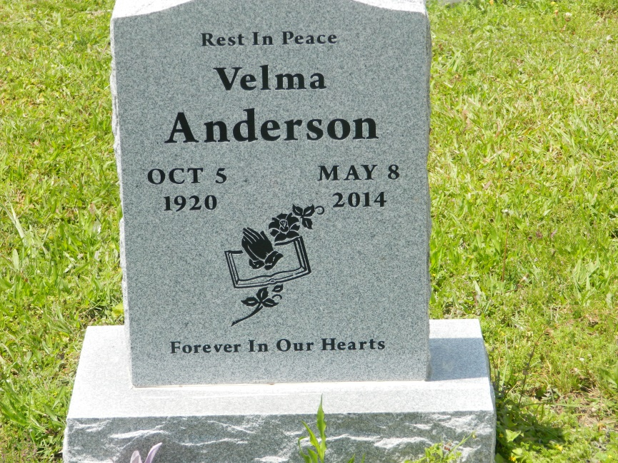

Velma Joseph Sheperd Anderson, a soldier in the Army of the Lord, peacefully transitioned to her Heavenly Home on Thursday May 8, 2014 at 11:11 p.m. at University Hospital at the age of 93. She was a native of Edgard, La. and resident of New Orleans, La. She was recognized as the mother of KFS Ministries under the leadership of Pastor George Guidery. She leaves to cherish her memories her devoted children Romalice (Loreta), Alvin (Lillian), Ethel Mae Anderson Fazande, Patricia Ann Anderson and Sandra Anderson Black. Also survived by (23) grandchildren, a host of great-grandchildren, and great-great grandchildren, cousins and other relatives and friends. She was preceded in death by her parents Vernon Joseph and Mary Clement Calahan, her step-father Herman Calahan, husband Edward Anderson, 3 late sons, Lawrence Sheperd, Jr., Larry and Michael Anderson.  
  
Relatives and friends of the family, members and former members of St. Paul #4, King Solomon, and First House of Prayer (KFS Ministries), Holy Trinity and neighboring churches are invited to attend the Homegoing Celebration on Saturday May 24, 2014 for 11:00 a.m. at First House of Prayer (KFC Ministries) 2826 LaSalle Street, New Orleans, La. Pastor George Guidery officiating. Visitation from 10:00 a.m. until 11:00 a.m. Interment: Young Cemetery, Edgard, La.  
  
Professional Services Entrusted To Estelle J. Wilson Funeral Home, Inc, 2715 Danneel Street, N.O. La. 70113; Betty P. Wilson-Dejoie (Director); Information: (504) 895-4903. To sign online guest book, please visit [www.estellejwilsonfuneralhome.com](http://www.estellejwilsonfuneralhome.com)

**Times-Picayune, The (New Orleans, LA) - Friday, May 23, 2014**

**Contributed by Jane Edson**