Shenita Marie Antonio

May 14 – July 29, 2013

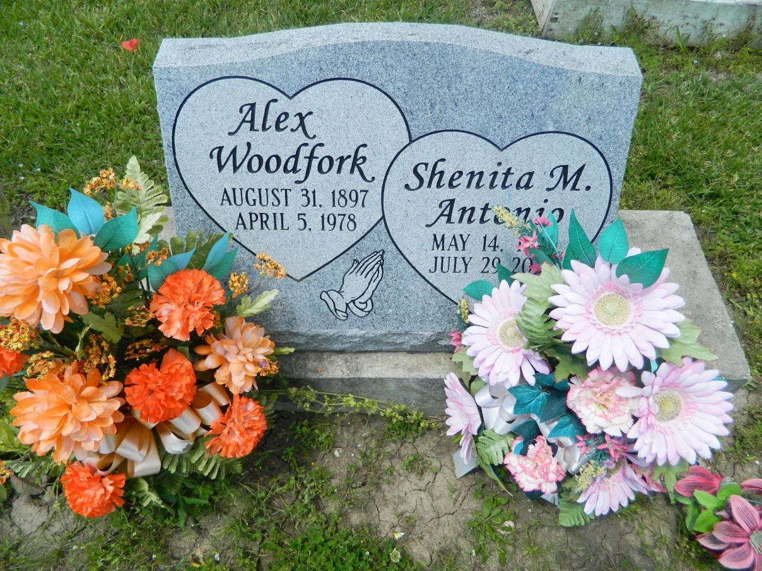

Shenita Marie Antonio, a native of Edgard, La., resident of Houma, La., departed this life on Monday, July 29, 2013. Daughter of Edgar and Erma Antonio. Sister of Edgar "Bobby" Antonio, Jr., Lelia (Charles) Feist, Danny (Allison) Antonio, and Lonnie (Catrena) Antonio. Also survived by a host of aunts, uncles, nieces, nephews, cousins, other relatives and friends.  
  
Relatives, friends, members of New Zion Baptist Church of Houma, La., employees of Louisiana Workforce Commission, West St. John High School Class of 1994 are invited to attend the funeral services at the Greater New St. Peter Baptist Church, 200 W. 3rd Street, Edgard, La., on Saturday, August 3, 2013 for 11:00 a.m. Visitation will be from 9:00 a.m. until time of service. Rev. Vernon Alexander will be officiating. Interment will be at St. Peter Baptist Church Cemetery, Edgard, La. Funeral entrusted to The Baloney Funeral Home, LLC., 1905 W. Airline Highway, Laplace, La., 985-224-8460. Condolences can be expressed at [www.baloneyfuneralhome.com](http://www.baloneyfuneralhome.com).

**Times-Picayune, The (New Orleans, LA) - Friday, August 2, 2013**

**Contributed by Jane Edson**