Stafford Augusta

Abt. 1940 – May 14, 2000

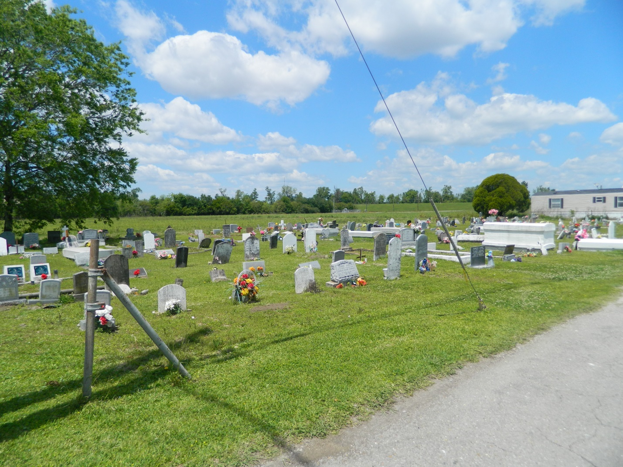

LULING - Stafford "The Bird" Augusta, 60, a native and resident of Edgard, died May 14. He was the father of Daniel Parquet. He was also the brother of Earl Augusta and Wilhelmina Simmons. He is also survived by two grandchildren. Services were May 18 at New St. Peter Baptist Church, Edgard, with interment at Young Cemetery.

**L'Observateur, LaPlace, LA; May 19, 2000**