Dwight Joseph Bastian

November 24, 1951 – August 10, 2004

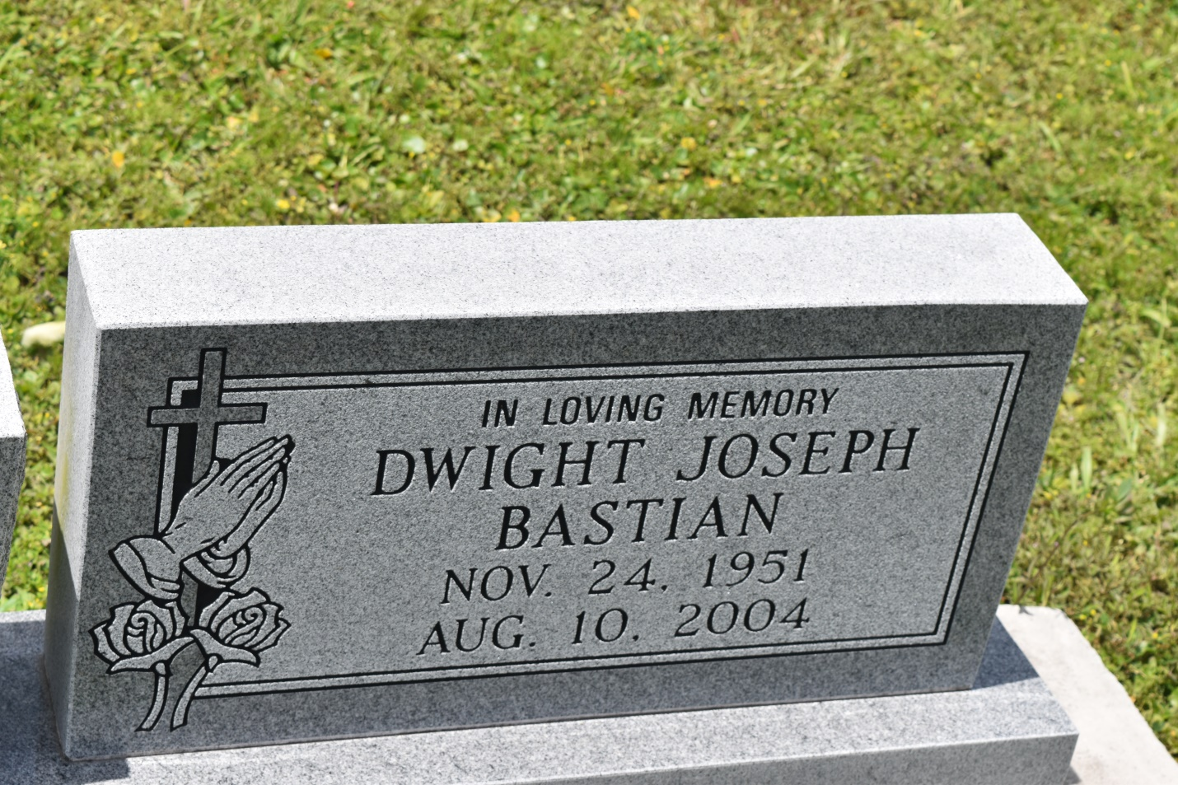

Dwight Joseph Bastian of Edgard, La passed away on Tuesday, August 10, 2004 at 11:45 AM at St. Charles Hospital, Luling, La. Beloved Husband of Judy H. Bastian. Son of the late Lowel I. and Elsie Narcisse Bastian. Father of Desmone Anthony 'Danine' Of Vancouver B. C. And Dwayne Michael Bastian of New Orleans, La. Brother of Theory B. 'Kevin' Verrett, Lowell Ii and the late Dr. Tyronne Bastian. Grandson of Pearl Bastian and the late Felix Joseph and the late Isiah and Florence Williams. Also Survived By '4' Sisters-In-Law, '4' Brothers-In-Law, A Host Of Aunts, Uncles, Nieces, Nephews, Cousins And Friends. A Native of Wallace, La. and a resident Of Edgard, La. Age 52 Years.

**Unknown source**

*****

Dwight Joseph Bastian, a retired laborer, died Aug. 10 at St. Charles Hospital from injuries sustained in a car accident. He was 52. Mr. Bastian was born in Wallace and lived in Edgard. Survivors include his wife, Judy H. Bastian; two sons, Desmone Bastian and Dwayne Bastian; a sister, Theory B. Verrett; and a grandchild. A funeral will be held Saturday at 11 a.m. at Second African Baptist Church, 136 W. Third St., Edgard. Visitation will begin at 8:30 a.m. Burial will be in Young Cemetery in Edgard. The Baloney Funeral Home is in charge of the arrangements.

**Times-Picayune, The (New Orleans, LA) - Saturday, August 14, 2004**

**Contributed by Jane Edson**