Lucinda Batiste

November 26, 1912 – April 4, 2013

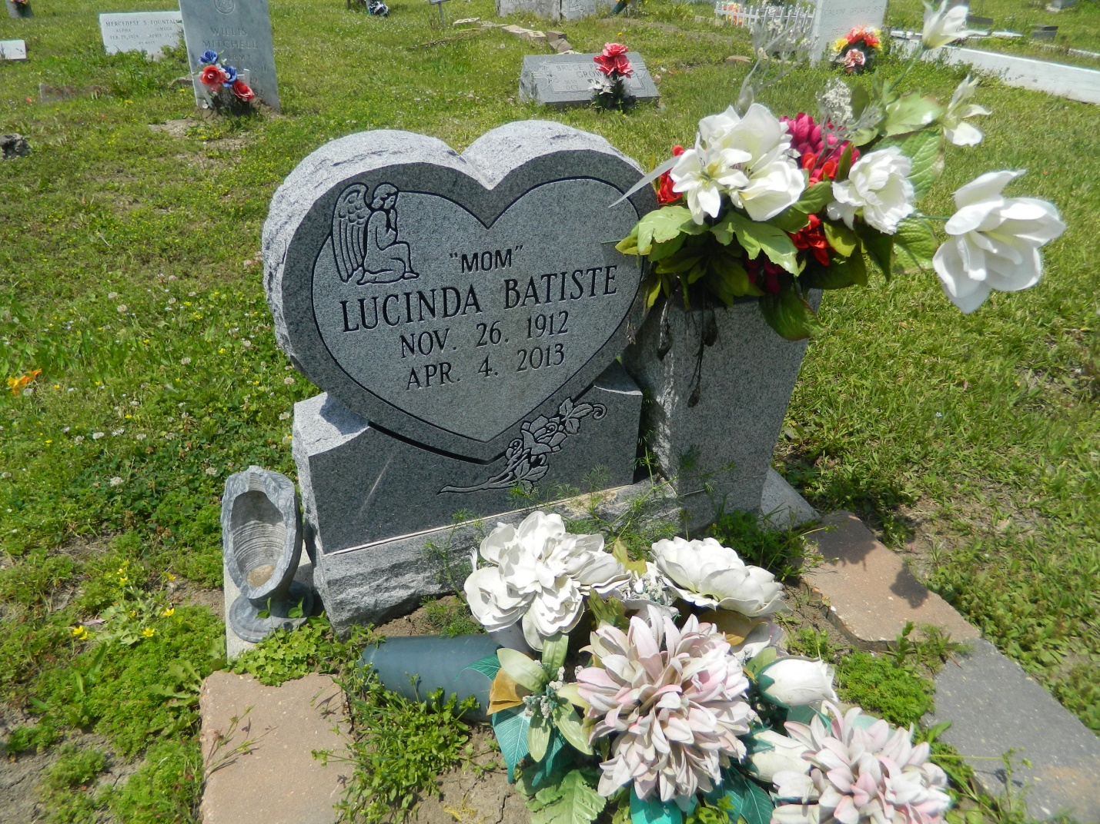

Lucinda Batiste passed away on April 4, 2013, at the age of 100 years old. Wife of the late Walter Batiste. Mother of the late Felton (the late Thelma) Turner, the late Elliot (Edith) Turner. Guardian of Gerald (Adaline) Turner. Also survived by a host of grandchildren, nieces, other relatives and friends.  
  
Funeral services will be held on Tuesday, April 9, 2013 for 11:00 a.m. at Greater New St. Peter Baptist Church, 200 W. 3rd Street, Edgard, La. Rev. Vernon Alexander will be officiating. Visitation will be from 9:00 a.m. until time of service. Interment will be at Young Cemetery, Edgard, La. Funeral entrusted to The Baloney Funeral Home, LLC., 1905 W. Airline Highway, Laplace, La., 985-224-8460. Condolences can be expressed at [www.baloneyfuneralhome.com](http://www.baloneyfuneralhome.com).

**Times-Picayune, The (New Orleans, LA) - Sunday, April 7, 2013**

**Contributed by Jane Edson**