Celena (Poche) Crockett

November 26, 1926 – June 5, 2009

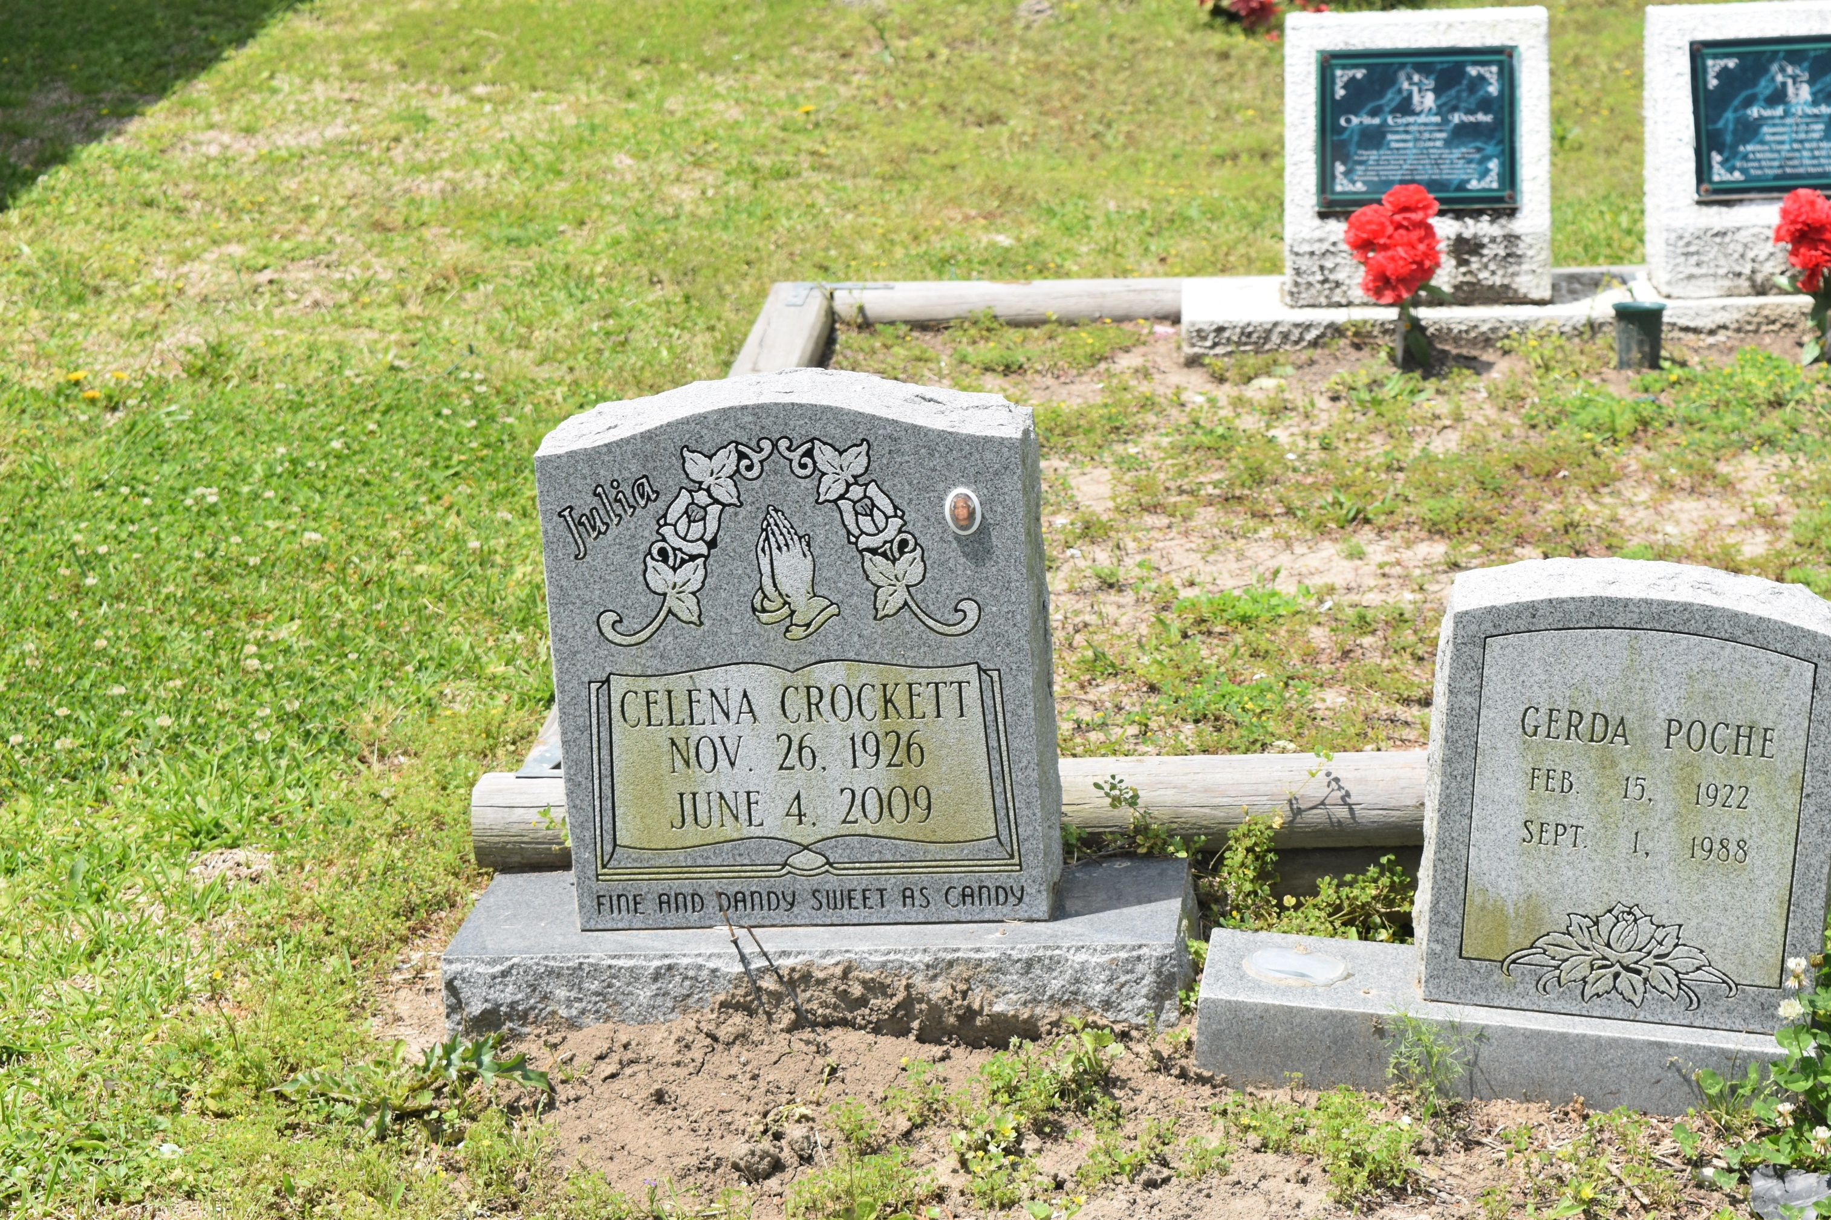

Celena Poche “Julia” Crockett, 82, of Baton Rouge, went home to rest on Friday, June 5, 2009. Left to cherish her memory are daughters, Lillie Heggins, Debbie Provost, Claudette Purnell and Barbara Allen; and sons, Ronald Crockett, Donald Crockett, Michael Crockett and Gerald Williams. Visitation at Hall Davis & Son Funeral Home, Port Allen, on Friday, June 12, from 1 p.m. to 5 p.m. Religious service at Union Baptist Church, Brusly, at 10 a.m. Saturday. Arrangements entrusted to Hall Davis & Son Funeral Service.

**Advocate, The (Baton Rouge, LA) - Thursday, June 11, 2009**

**Contributed by Jane Edson**