Linda Marie (Howard) Dupard

October 20, 1952 – October 4, 2012

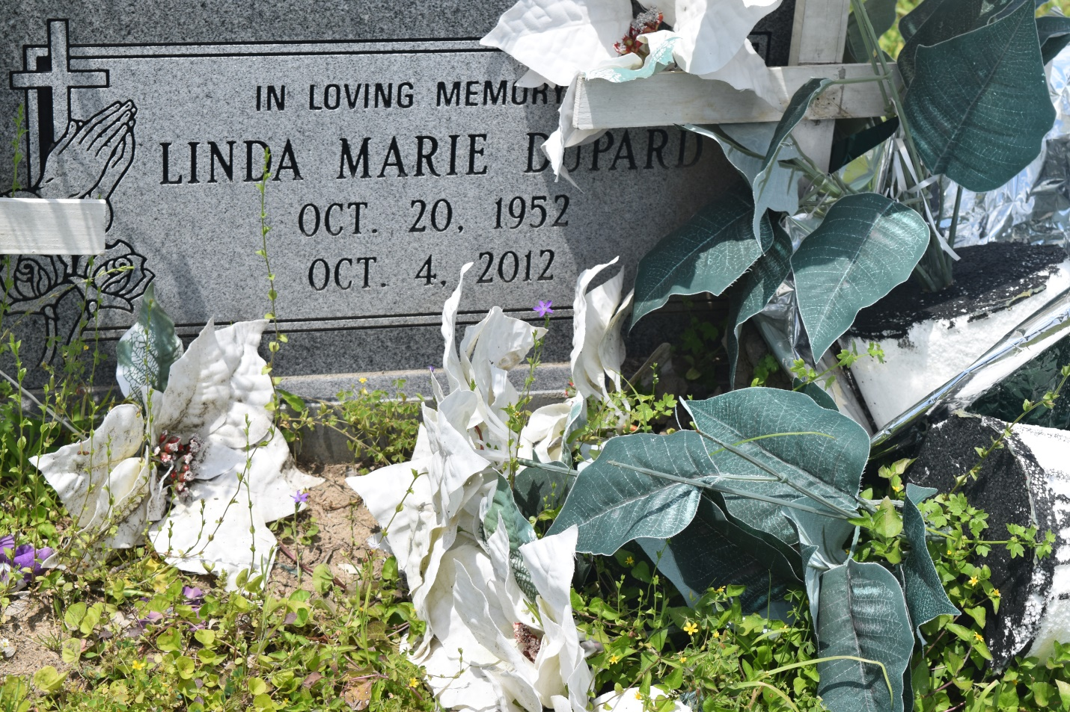

Linda Marie Howard Dupard "Peanaie"  
  
Born October 20, 1952. Went home October 4, 2012. She was preceded in death by her parents John and Vanessa Howard; 2 sisters Irene and Gloria Howard; 2 brothers Oniel and Frank Howard, and her friend Ellis Stewart. She was the mother of Brian Howard, Sr. (Letitia) of Luling, LA; Zinna Leonard (Rapheal) of Kenner, LA.; and Victor Dupard (Java) of Wallace, LA. She leaves to cherish her memories, 5 sisters Mary Stewart of Boutte, LA, Iris Lewis, Laura Mae Howard, and Brender Howard of Edgard, LA, and Rose Howard of Paulina, LA.; 3 brothers Glenn Howard of Vacherie, LA, Jessie, and Phillip Howard of Edgard, LA. A host of nieces, nephews, cousins, other relatives and friends.  
  
Relatives and friends of the family, Ormond Nursing Care Center, and Luling Nursing Home are invited to attend the funeral service at New St. Peter Baptist Church, 200 West 3rd Street, Edgard LA 70049, on Saturday, October 13, 2012, at 11 am. Visitation will begin at 9 am. Burial will be in Young Cemetery. Courtney Baloney, Funeral Director. Arrangements by Heritage Funeral Directors (504) 944-5500.  
  
Online guest registry book at [www.heritagefuneraldirectors.com](http://www.heritagefuneraldirectors.com).

**Times-Picayune, The (New Orleans, LA) - Friday, October 12, 2012**

**Contributed by Jane Edson**