Olevia (Poche) Forest

February 18, 1936 – March 18, 2012

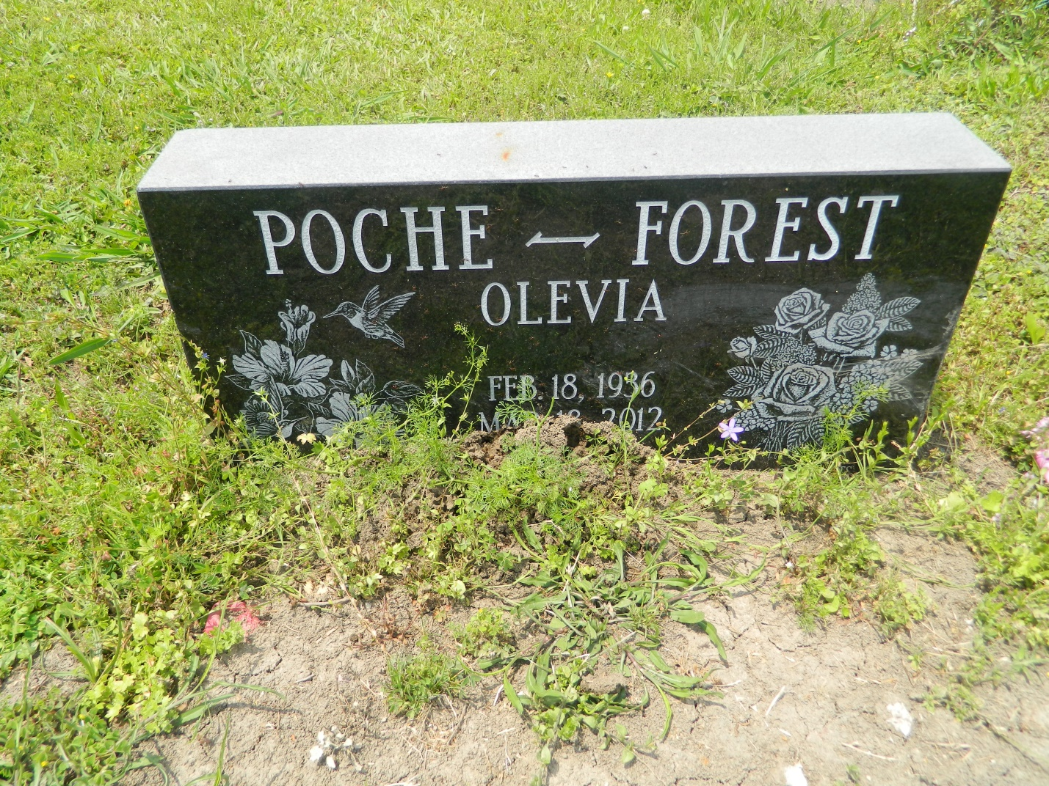

Sister Olevia Poche Forest, a homemaker, died Sunday, March 18, 2012, of heart failure at her home in Jonesboro, Ga. She was 76. Mrs. Forest was a lifelong resident of New Orleans, LA until Hurricane Katrina relocated her to Riverdale, Ga. She was a member of Fountain of Faith M.B.C. in Riverdale, Ga. where she served as the Vice President of the Motherboard. Survivors include six daughters: Gardenia Mitchell Dobard and Elnora Forest of Riverdale, Ga., Alice Braddy of Austin, Tx., Tammy Forest Jackson, Stephanie Forest Barnes, and Cathy Forest; goddaughter, Rita Jarrow all of New Orleans, La.; 16 grandchildren and 32 great-grandchilden. A funeral will be held Monday, March 26, 2012 at 11:00 a.m. at Rock of Ages Baptist Church, 6533 Acre Rd., Marrero, LA 70072. Pastor Felton Williams of Greater Faith Baptist Church, officiating. Burial will be at Young Cemetery, Edgard, LA. MJR Friendly Service Funeral Home is in charge of arrangements.

**Times-Picayune, The (New Orleans, LA) - Sunday, March 25, 2012**

**Contributed by Jane Edson**