Patricia Ann Francis

Abt. 1958 – January 6, 2000

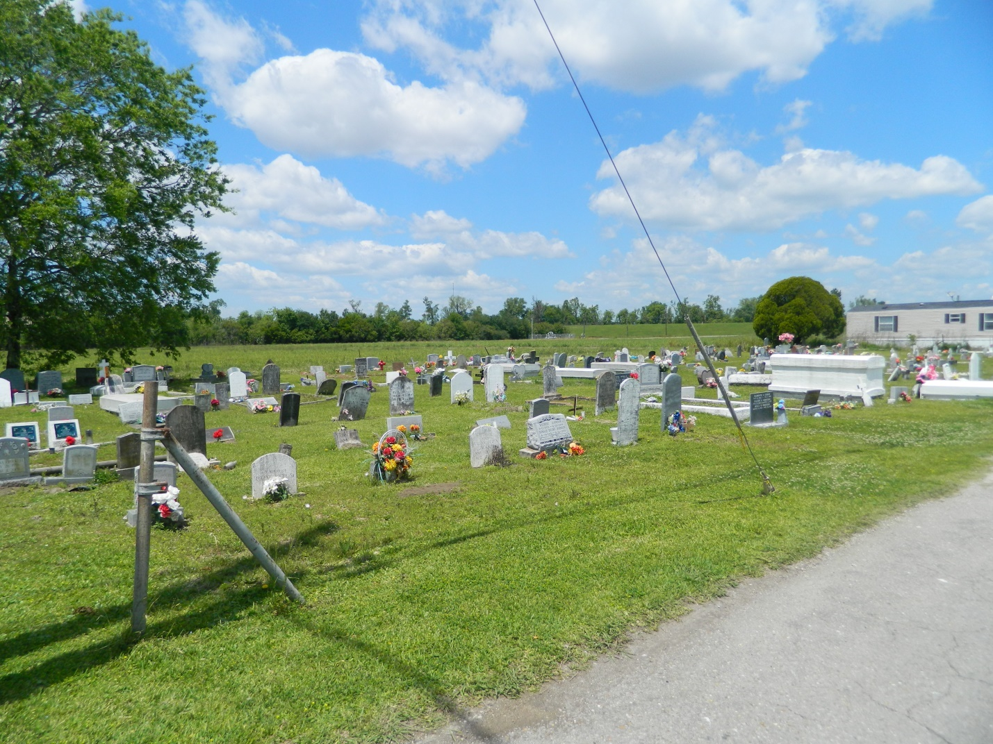

EDGARD - Patricia Ann Francis, 42, a native of Edgard and resident of LaPlace, died Jan. 6. She was the mother of Sherrie, Keisha and Natasha Francis. She was also the daughter of Willie Francis and the late Albertha Narcisse Francis and sister of Denise Lewis, Mary Keller and Willie Jr., Dennis, Michael, Wayne and the late Corrine Francis. Services were held Jan. 11 at Greater New St. Peter Baptist Church, Edgard, with interment at Young Cemetery, Edgard.

**L'Observateur, LaPlace, LA; January 12, 2000**