Jessie Hall Sr.

February 15, 1935 – October 11, 2013

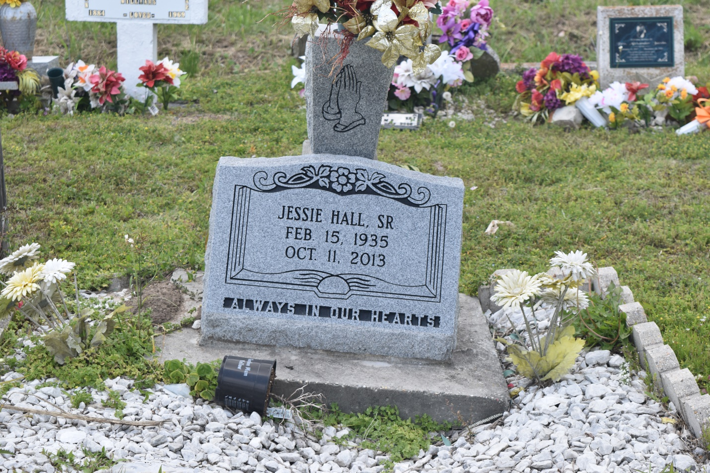

Jessie "JT" Hall Sr. at the age of 78 yrs. departed this earthly life and entered into eternal rest on Friday, October 11, 2013 at Kindred Hospital of New Orleans, LA. Beloved husband of the late Mildred Ross Hall. Devoted father of Jessie Hall Jr. (Carmella), Charlotte Hall, Marcelin Brisco, and Chivan Hall. He was the grandfather of 10, great-grandfather of 8, also survived by 1 sister, 1 brothers, a host of nieces, nephews, other relatives, and friends. He was preceded in death by his wife Mildred Ross Hall, mother and father Rozelia Marshall and Washington Hall Sr. and 11 siblings and one grandchild, Jessie H. Hall III.  
  
Relative and friends of the family, also pastors, officers, and members of Second African Baptist Church of Edgard, LA, Second New Zion Baptist Church, Employees of Wal-Mart and all neighboring churches are invited to attend the funeral services on Saturday, October 19, 2013, at 11:00am. at The Second African Baptist Church at 136 W. 3rd St. Edgard, LA. Rev. Clarence Z. Mollaire Pastor, Rev. Joseph Isaac officiating. Interment in Young Cemetery. Visitation will be at the above named church from 10:00 am. until 11:00 am.  
  
Bardell's Mortuary of Mt. Airy, LA in charge. Information: 985-535-6837.

**Times-Picayune, The (New Orleans, LA) - Friday, October 18, 2013**

**Contributed by Jane Edson**