Lawrence Howard Sr.

December 28, 1939 – September 19, 2004

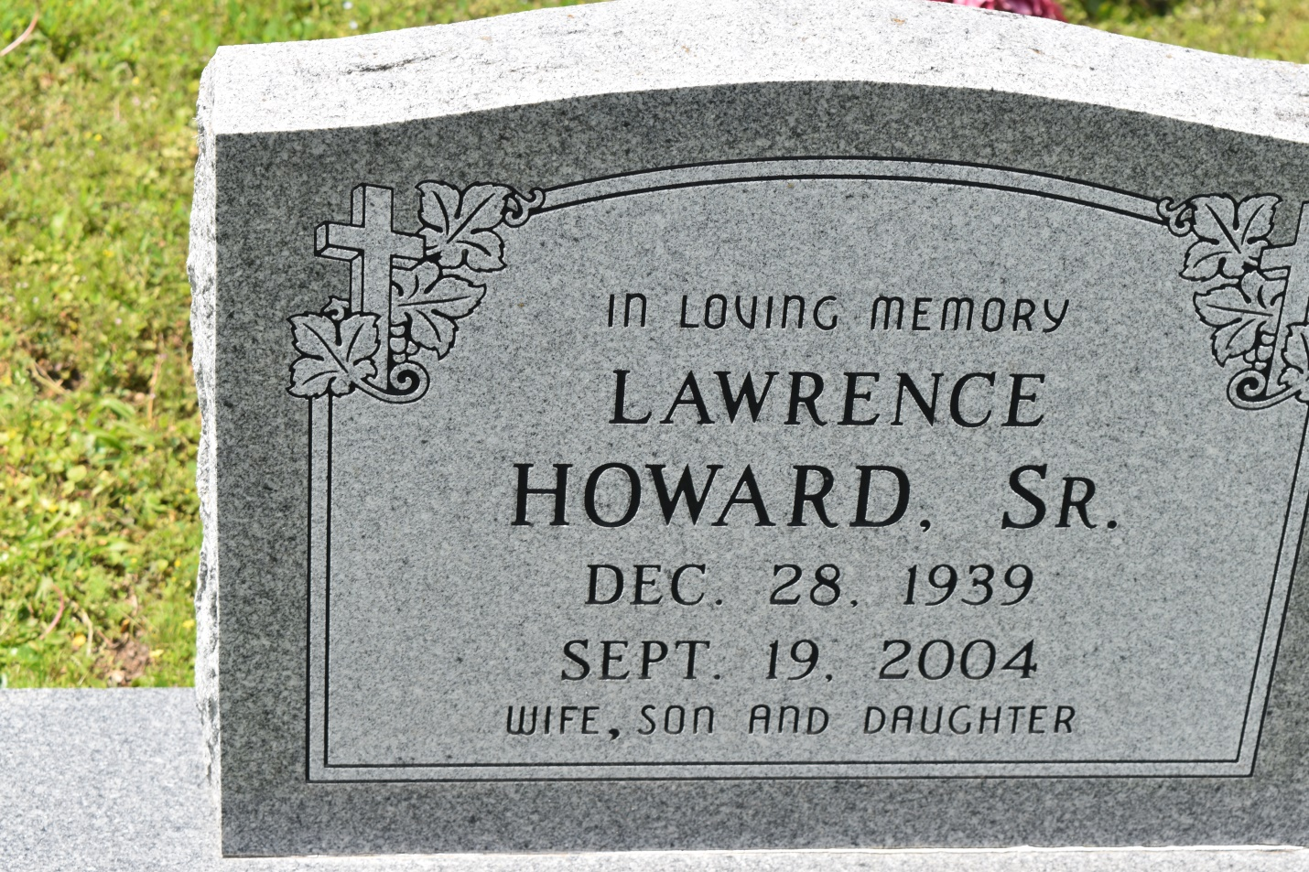

Lawrence "Koo Ta" Howard, a contract laborer for Monsanto, died Sunday of congestive heart failure at St. Elizabeth Hospital. He was 64. Mr. Howard was a lifelong resident of Wallace. He was an usher at Greater New St. Peter Baptist Church. Survivors include his wife, Gloria Mae Narcisse Howard; a son, Kevin Howard; a daughter, Donna Howard; two sisters, Laura Howard and Leontine Narcisse; and three grandchildren. A funeral will be held today at 11 a.m. at Greater New St. Peter Baptist Church, 200 W. Third St., Edgard. Visitation will begin at 9 a.m. Burial will be in Young Cemetery. Bardell's Mortuary is in charge of arrangements.

**Times-Picayune, The (New Orleans, LA) - Saturday, September 25, 2004**

**Contributed by Jane Edson**