Marion Catherine (Williams) Jacobs

January 23, 1918 – July 2, 2014

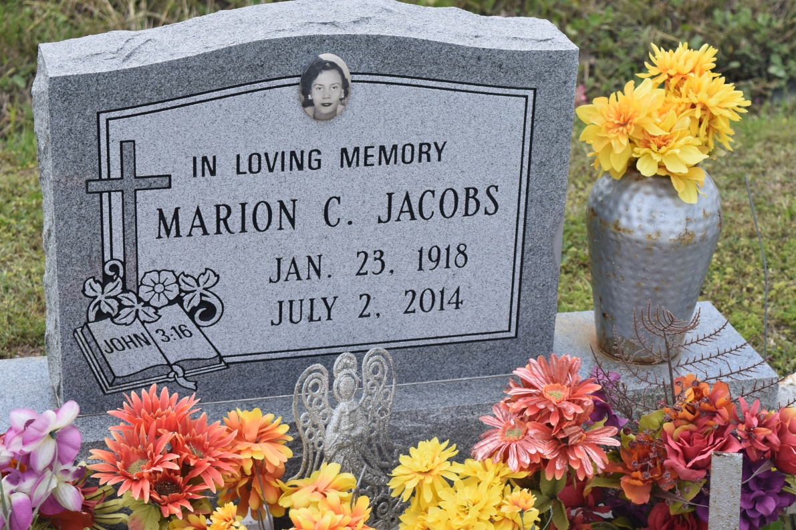

Marion Catherine Williams Jacobs "Bee, Annie Mae, Maion", entered eternal rest on Wednesday, July 2, 2014 at the age of 96. She is preceded in death by her beloved husband, the late Alexander Jacobs, her beloved parents; Joseph and Agnes Adams Williams, two brothers; Alvin and Dallas Williams, one brother-in-law; Emile Gaudet, and one sister-in-law; Beverly Williams.  
 Marion leaves to mourn her four daughters; Vivian J. Irons (Charles), Rosa J. Marquez (Theodore), Martha Williams (Keith), and Carolyn Preston. One sister; Clara Williams Gaudet, one sister-in-law; Felicia Edwards Williams, and one godchild; Sherlyn Gaudet. Also mourns are her 17 grandchildren, 33 great-grandchildren and 9 great great-grandchildren and a host of   
relatives and friends.  
 Relatives, friends of the family, and church members are invited to attend the funeral services at Greater New St. Peter Baptist Church, 200 W 3rd St., Edgard, La., Saturday, July 12, 2014 at 11:00 am.  
 Visitation will be from 9:00 a.m. until time of service. Rev. V. Alexander will be officiating. Interment will be at Young Cemetery, Edgard, La. Funeral entrusted to The Baloney Funeral Home, LLC, 1905 W. Airline Highway, Laplace, La., 985-224-8460.  
  
Condolences can be expressed at [www.baloneyfuneralhome.com](http://www.baloneyfuneralhome.com)

**Times-Picayune, The (New Orleans, LA) - Friday, July 11, 2014**

**Contributed by Jane Edson**