Jimmie Johnson Sr.

July 21, 1910 – July 24, 2000

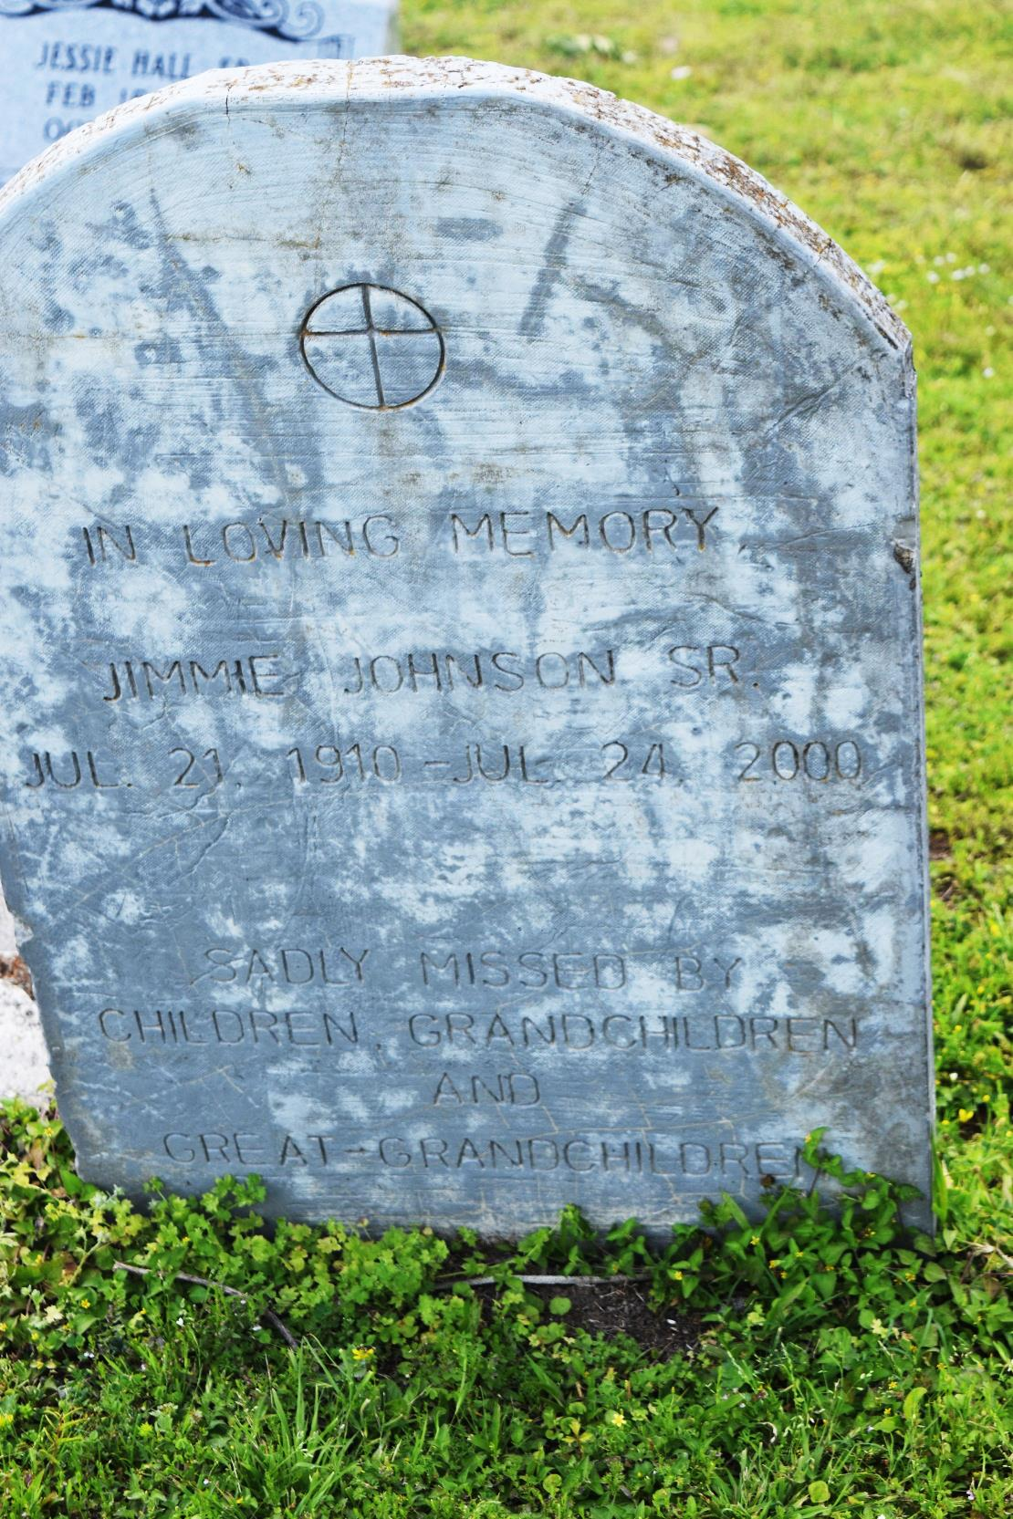

Jimmie Johnson Sr., a retired longshoreman, died Monday at Ochsner Foundation Hospital. He was 90. Mr. Johnson was born in Edgard and lived in Marrero for the past 57 years. He was a member of Morning Star Baptist Church, where he served on the Beautifying Club. Survivors include a son, Walter Johnson; four daughters, Leona Howard of Dayton, Ohio, Dorothy Scanks of Sylmar, Calif., Willeana Haydel and Orelia Vance; 14 grandchildren; 26 great-grandchildren; and two great-great-grandchildren. A funeral will be held Saturday at 11 a.m. at Morning Star Baptist Church, 1000 Cross St., Marrero. Visitation will begin at 8 a.m. Burial will be in Young Cemetery in Edgard. D.W. Rhodes Funeral Home is handling arrangements.

**Times-Picayune, The (New Orleans, LA) - Friday, July 28, 2000**

**Contributed by Jane Edson**