Mark Anthony Johnson

Abt. 1959 – November 25, 2009

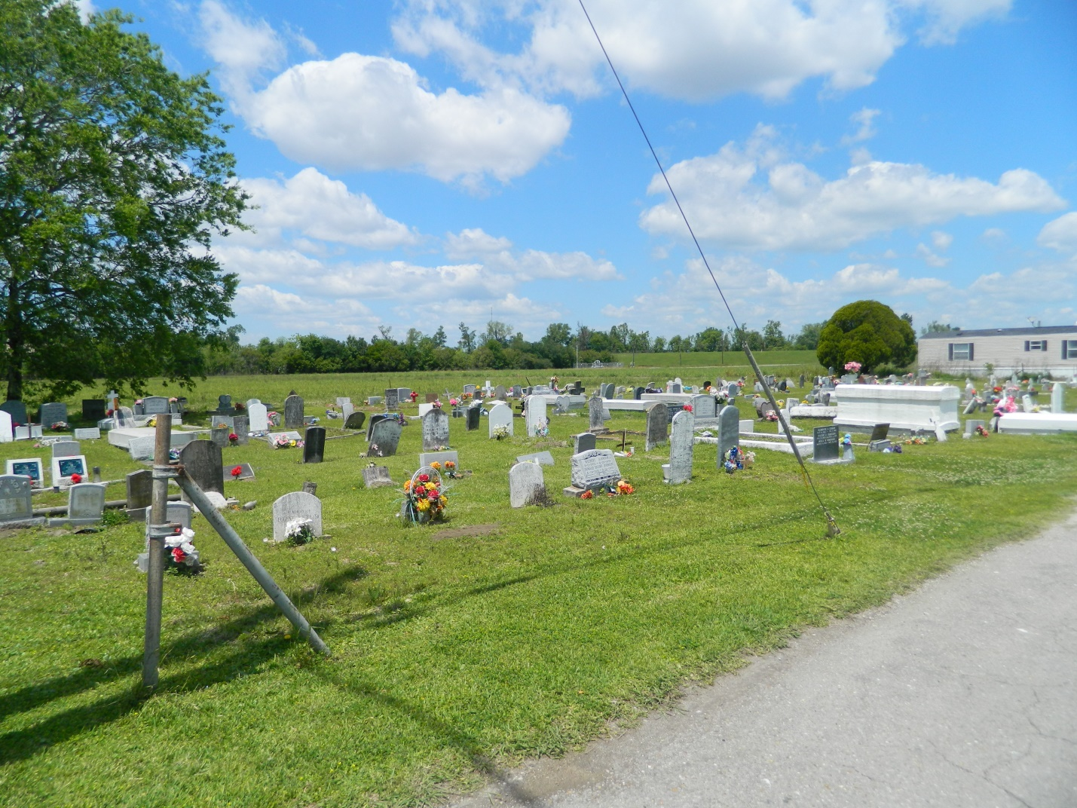

JOHNSON  
  
Mark Anthony Johnson on Wednesday, November 25, 2009 at Ochsner-Kenner, Kenner, LA. Son of Wimberly Johnson and the late Jennetta Washington Johnson. Companion of Dottie Young. Father of three sons. Brother of one sister, nine brothers. Also survived by 2 grandchildren and a host of nieces and nephews other relatives and friends. Age 50 years. A native and resident of Edgard, LA.

Relatives and friends of the family, also pastors, officers and members of the Greater St. Peter Baptist Church and all neighboring churches are invited to attend the funeral at Greater St. Peter Baptist Church, 200 West Third Street, Edgard, LA on Wednesday, December 2, 2009 at 11:00 A<. Rev Vernon Alexander, Pastor, Officiating. Interment Young Cemetery, Edgard, LA. Visitation at the above named church from 10:00 AM until service.

**The Times-Picayune, Tuesday, December 1, 2009, B-6**