Allen Lewis

September 9, 1951 – December 18, 2016

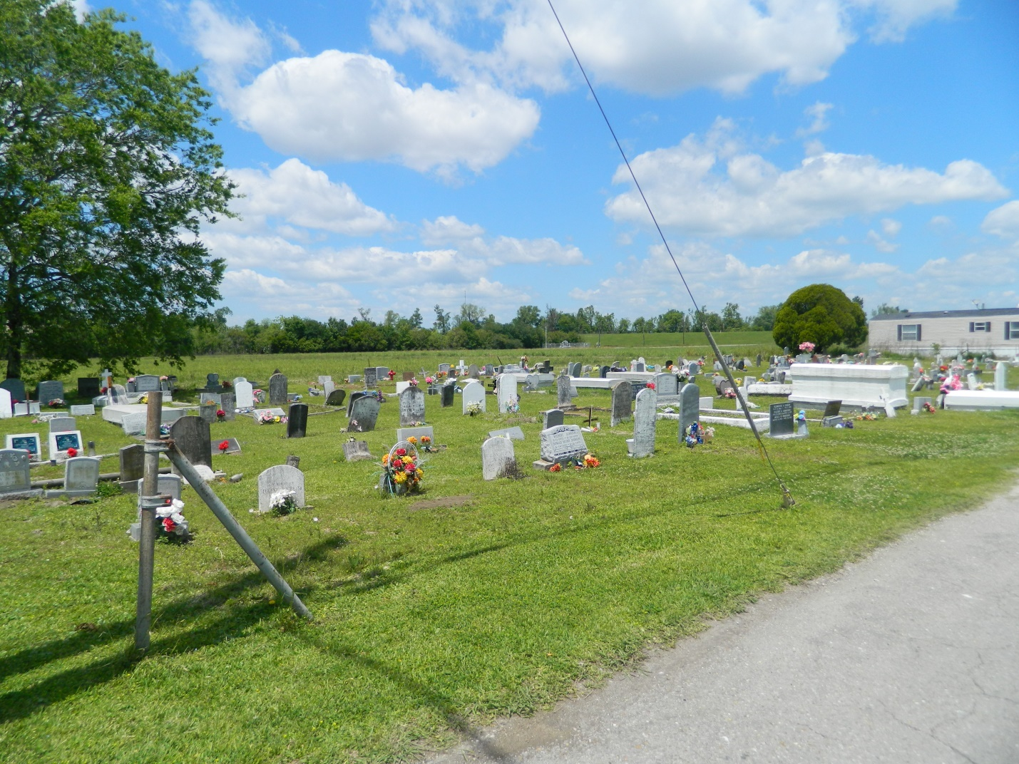

Allen “Pop” Lewis departed this life on Sunday, December 18, 2016 at the age of 65.  
  
Beloved husband of Anna F. Lewis. Loving father of LaTerrance (Erica), Shane (Dionne), and Ryan Lewis. Stepfather of Bridget (Burnell) Hall and Crystal (Wilfred) Armant. Son of the late Gaston and Carrie Lewis. Brother of Alvin (Lynn), Clyde (Karen) Lewis, Sandra (Roy) Simmons, Adrienne (Charles) Allen and the late Gaston, Harold and Carolyn Lewis; also survived by a host of grandchildren, 1 great grandchild, sisters-in-law, brothers-in-law, nieces, nephews, cousins, other relatives and friends.   
  
Relatives and friends of the family, also pastors, officers, and members of Rock of Ages Missionary Baptist Church and all neighboring churches are invited to attend the Funeral Service at Rock of Ages Baptist Church, 6533 Acre Rd. Marrero, LA on Tuesday, December 27, 2016 at 10:00 a.m.  Pastor Gilbert Barnes, officiating. Visitation will begin at 8:00 a.m. until service time.  Interment: Young Cemetery-Edgard, LA

**Published in TheNewOrleansAdvocate.com from Dec. 21 to Dec. 27, 2016**