Marion (Favorite) Lewis

May 4, 1943 - December 20, 2019

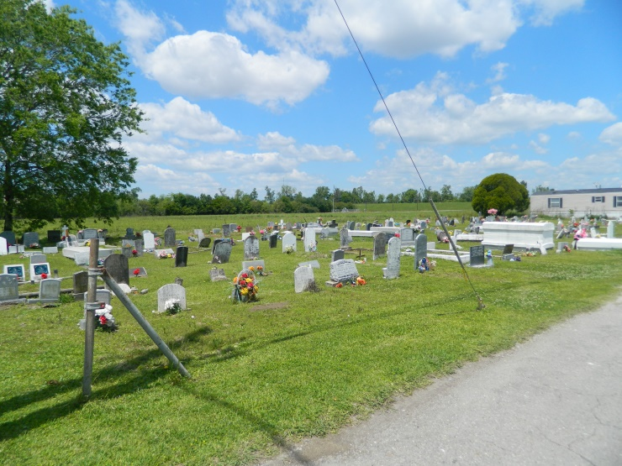

Marion “Ma-Me” Lewis, age 76 years departed this life at her residence in Edgard, LA on Friday, December 20, 2019. Beloved wife of the late Cosey Lewis, Jr. Daughter of the late Samuel Sr., and Virginia Favorite. Mother of Conrad (Denise) Lewis, Shawn (Charlotte) Lewis, Robin (Jolies) Lewis, Brandie (Rhondele) Williams, and Jason (Brittany) Lewis. Sister of Margaret Henderson, Shirley Grows, Vivian Chopin, Anna Mae Lewis, Geraldine Boose, Josephine Favorite, and Larry Favorite. Godmother of Gregory Grows. Devoted friend, Amy Narcisse and niece, Bridget Hall. Marion is also survived by 19 grandchildren, 3 great grandchildren, 1 sister-in-law, 1 brother-in-law, a host of nieces, nephews, cousins, other relatives and friends.   
 Relative and friends of the family, also Pastors, officers and members of the Greater New St. Peter Baptist Church and all neighboring churches, employees of the St. John the Baptist Clerk of Court, Entergy, Assumption Parish Sheriff’s Office, and Turner Industry Group are invited to attend the funeral services on Saturday, December 28, 2019 at 11:00 A.M. held at Greater New St. Peter Baptist Church, 200 West 3rd St. Edgard, LA, Pastor Vernon Alexander, officiating. Visitation begins at 9:00 A.M. Interment] will follow at Young Cemetery Edgard, LA. Final care entrusted to Treasures of Life Funeral Services, 315 E. Airline Highway, Gramercy, LA 70052.

Treasure of Life Funeral Services, Gramercy, LA (Accessed 1/29/2020)