Vernita (Bailey) Lewis

May 31, 1928 – May 2022

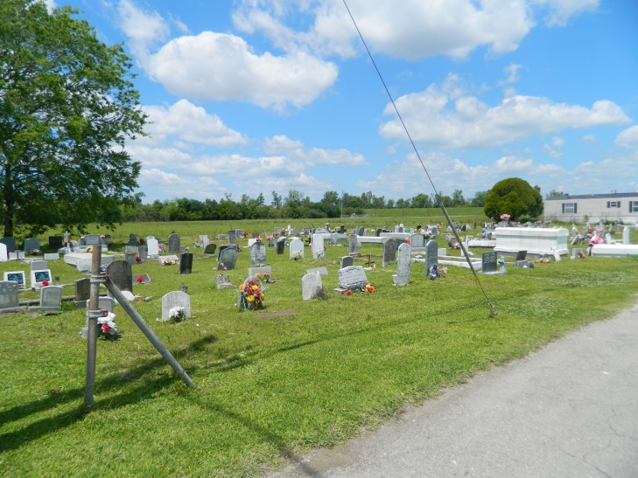

Minister Vernita B. Lewis, Matriarch of the Lewis family was called home after 93 years on earth. "We are just travelers on this earth and God is our eternal abode. Philippians 3:20" Vernita (affectionately known as Mommie) was born May 31, 1928, in Edgard, LA to the late Celestine Bailey and Ellen Washington-Bailey. She married the late Albert J. Louis Jr, in this union, they had nine children. Mommie always had a lovely smile on her face with such grace. She loved to talk to everyone and share her many stories. Those that know her, know she had a love for hats, as she wore a different hat for every church service she attended. She loved praising God with her Holy dance down the church aisles of many churches. She is survived by her children, Dolores Swatt, Ellen "Kim" Lewis, Mary Lewis, Albert "Blue" Lewis III, Patricia Taylor-Thomas, Solomon Lewis; Daughter-in- law, Mildred Lewis, Terry Lewis, along with 26 grandchildren and a host of great grandchildren. She is preceded by her children, Darryl J. Louis; Daughters, Brenda DeClouet-Riley, and Barbara J. Lewis; Grandchildren, Catrina Lewis, Cornell Lewis; and Son-in-law, Mark Thomas; sisters, Henrietta Bailey-Fletcher, and Corrine Lewis; and brothers, Solomon, Celestine, Percy, and Oscar Bailey. Family and friends are invited to celebrate in the Homegoing Celebration of their beloved matriarch on Saturday, May 21, 2022, at 10 am at Israelite Divine Spiritual Church, 3000 Frenchmen St. New Orleans, LA 70122. Visitation will begin at 9:00 am until service time. The Officiating Pastor is Archbishop William Wilson. Interment will follow at Young Cemetery, 185 West 3rd Street, Edgard, LA. Viewing will be held Friday, May 20, 2022, from 3 p.m. until 6 p.m. at Bardell's Mortuary, 3856 LA-44, Mt. Airy, LA 70076. Services entrusted to Bardell's Mortuary. Information: (985)535-6837.

Published by The Times-Picayune (New Orleans, LA) from May 18 to May 21, 2022.