Hoover J. Lorio Jr.

March 25, 1961 – July 28, 2014

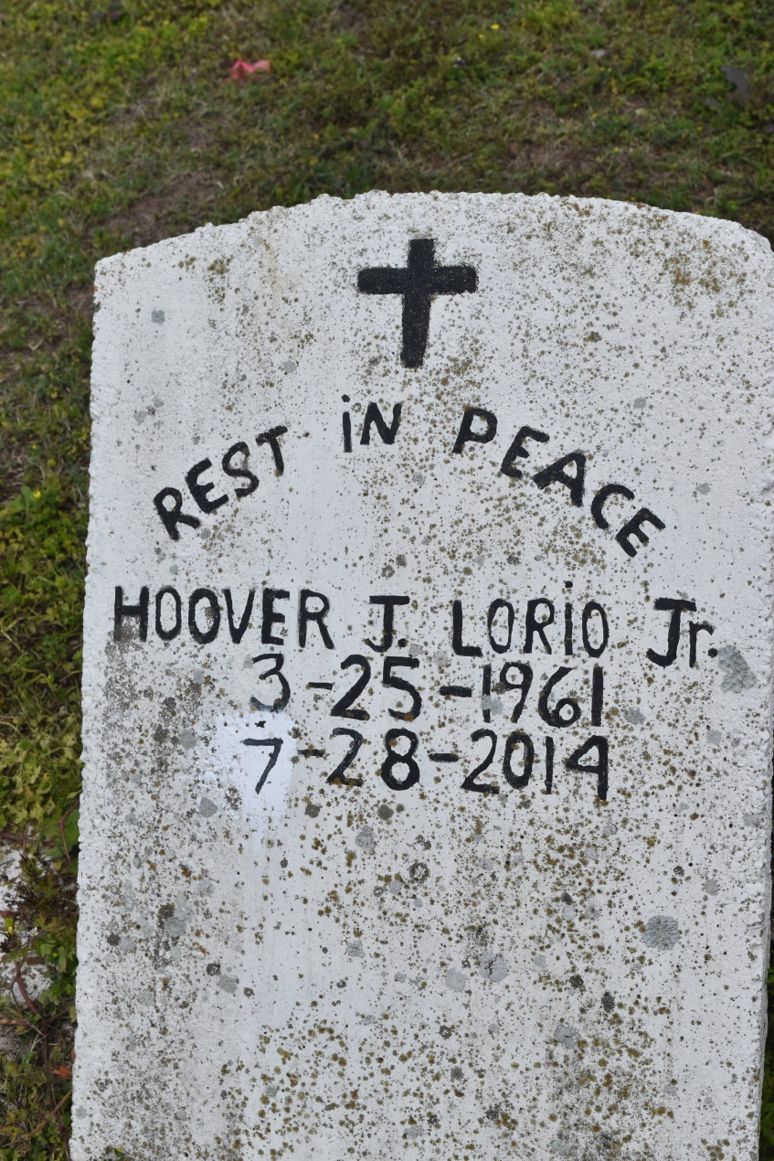

HOOVER LORIO, JR. "HOMES" on Monday, July 28, 2014 at The Sanctuary at Passages Hospice, New Orleans, LA. Son of the late Lorenza Johnson and Hoover Lorio, Sr. Father of Shera Bornes. Brother of Matthews Jackson, Aubrey Lorio, Glenn Lorio (Tanzer) and the late Jacqueline Lorio Ayo. Also survived by 6 grandchildren and a host of nieces, nephews, cousins other relatives and friends. Age 53 years. A native and resident of Edgard, LA.  
  
Relatives and friends of the family also pastors, officers and member of The Historic Bethlehem Baptist Church and all neighboring churches and graduates of West St John Class of 1979 are invited to attend the Funeral Service at The Historic Bethlehem Baptist Church, 14989 Highway 18 (River Road), Hahnville, LA on Saturday, August 2, 2014 at 11:00 AM. Rev. Rodney Johnson, Sr., Pastor, Officiating. Interment Young Cemetery, Edgard, LA. Visitation at the above named church from 9:00 AM until Service Time.  
  
SERVICED BY ROBOTTOM

**Times-Picayune, The (New Orleans, LA) - Friday, August 1, 2014**

**Contributed by Jane Edson**