Florence (Hebert) Milton

December 1, 1935 – February 11, 2022

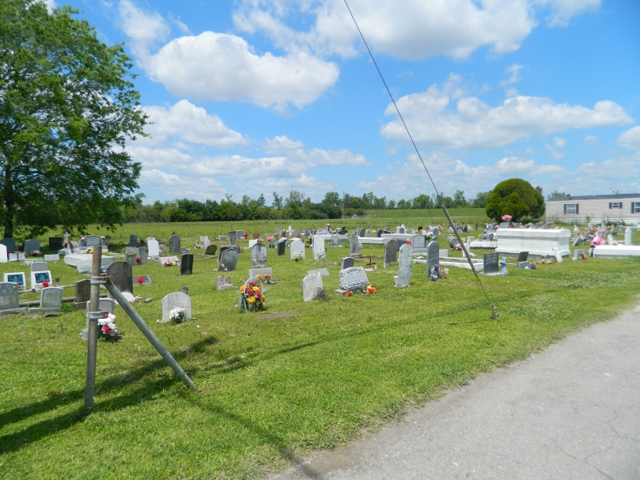

“And God shall wipe away all tears from their eyes; and there shall be no more death, neither sorrow, nor crying, neither shall there be any more pain; for the former things are passed away.” Revelations 21:4  
 Mrs. Florence “Miss Pete” Hebert Milton departed this life on Friday, February 11, 2022, at St. James Parish Hospital in Lutcher, Louisiana. She was born on December 17, 1935, in Wallace, Louisiana. She was the only child of the late Walter and Pamela Holly Hebert of Edgard, Louisiana. Florence married the love of her life Freddie Milton Sr., and from this union they reared six children: Zilda, Clara, Gayle, Brenda, Harriet, and Freddie Jr.  
 At a very early age, she was baptized by the late Reverend J.J. Harper and served under the leadership of Reverend Vernon Alexander until her passing. Florence loved her church family and served timelessly in many areas of the church. She was a licensed missionary, deaconess, member of the Christian Board of Education, and most of all a prayer warrior. The love of God and his word was her guide in life. She was loved by all, and she loved everyone. Florence made it her mission to spread God’s word wherever she went. Her whole life was a mission, doing God’s work.  
 To cherish her memories, Florence leaves behind her loving children, Zilda Dukes, Gayle Hilaire, Brenda Milton, and Harriet Gros; twelve grandchildren, Dryelle Washington (Melissa), Iran Washington (Chanda), Traviss Hilaire (Jennessa), Johnell Milton, George Winston III (Denisha), Demoine Gros, Jamal Gros, Chance Gros, Rasheda Owens (Ravane), Dashera Reed (Douglas), and Michael Gros Jr.; twenty-two great grandchildren and ten great-great grandchildren; one brother-in-law, Wilbert Milton Sr.; Godchildren, Crystal Gaudet and Abbie Gauthier; and a host of nieces, nephews, cousins, relatives, and friends.  
 She was preceded in death by her parents, Walter and Pamela Hebert; husband, Freddie Milton Sr.; son, Freddie Milton Jr.; daughter, Clara Milton; three brothers-in-law, Calvin, Clifford, and Benny; four sisters-in-law, Zilda, Ella, Dorothy, and Doris; and two sons-in-law, Reverend Joseph Hilaire Jr. and Michael Gros Sr.  
 Family and friends are invited to attend the funeral services on Saturday, February 19, 2022, at Second African Baptist Church, 136 W 3rd St., Edgard, LA 70049. Visitation period will be held from 9am-11am. Service will begin at 11am. Interment to follow at Young Cemetery (located down the street from the church). Final care and professional services entrusted to Treasures of Life Funeral Services, 315 E Airline Hwy., Gramercy, LA 70052.

Treasure of Life Funeral Services, Gramercy, LA

February 25, 2022