Freddie Milton Jr.

April 25, 1960 – November 19, 2000

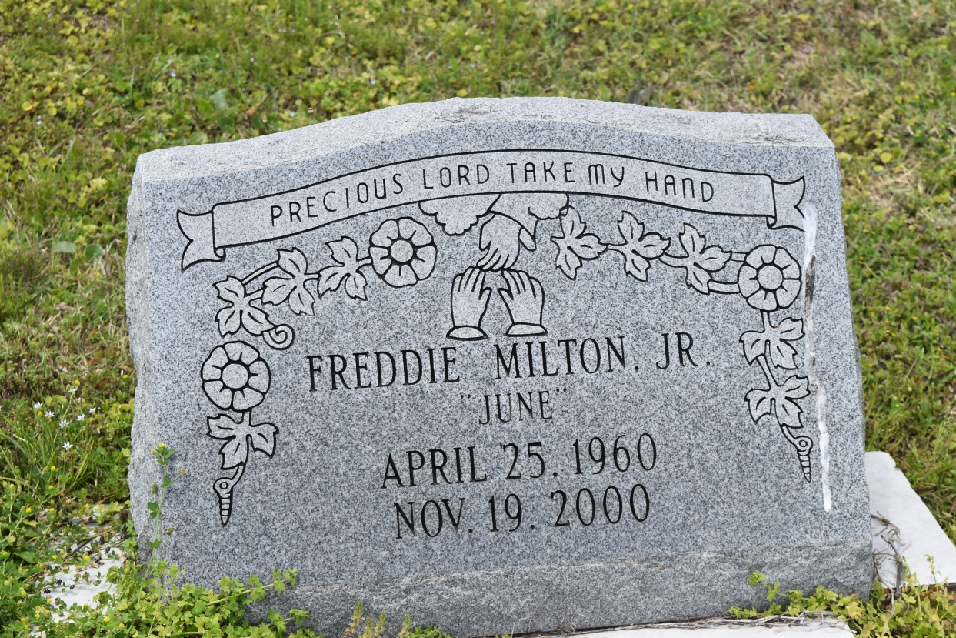

Freddie "June" Milton Jr., a former construction worker, died Nov. 19 of undetermined causes at St. Charles Parish Hospital in Luling. He was 40. Mr. Milton was a resident of Edgard. Survivors include his parents, Freddie and Florence Milton; and four sisters, Zilda Dukes of Kenner, Gayle Hilaire of LaPlace, and Brenda Milton and Harriet Gros. A funeral will be held Friday at 8 p.m. at Great New St. Peter Baptist Church in Edgard. Visitation will begin Friday at 5 p.m. Dismissal will be Saturday at 11 a.m. Burial will be in Young Cemetery in Edgard. Earl Baloney & Sons Mortuary is in charge of arrangements.

**Times-Picayune, The (New Orleans, LA) - Thursday, November 23, 2000**

**Contributed by Jane Edson**