Carolyn Dianna Morris

November 14, 1956 – September 8, 2017

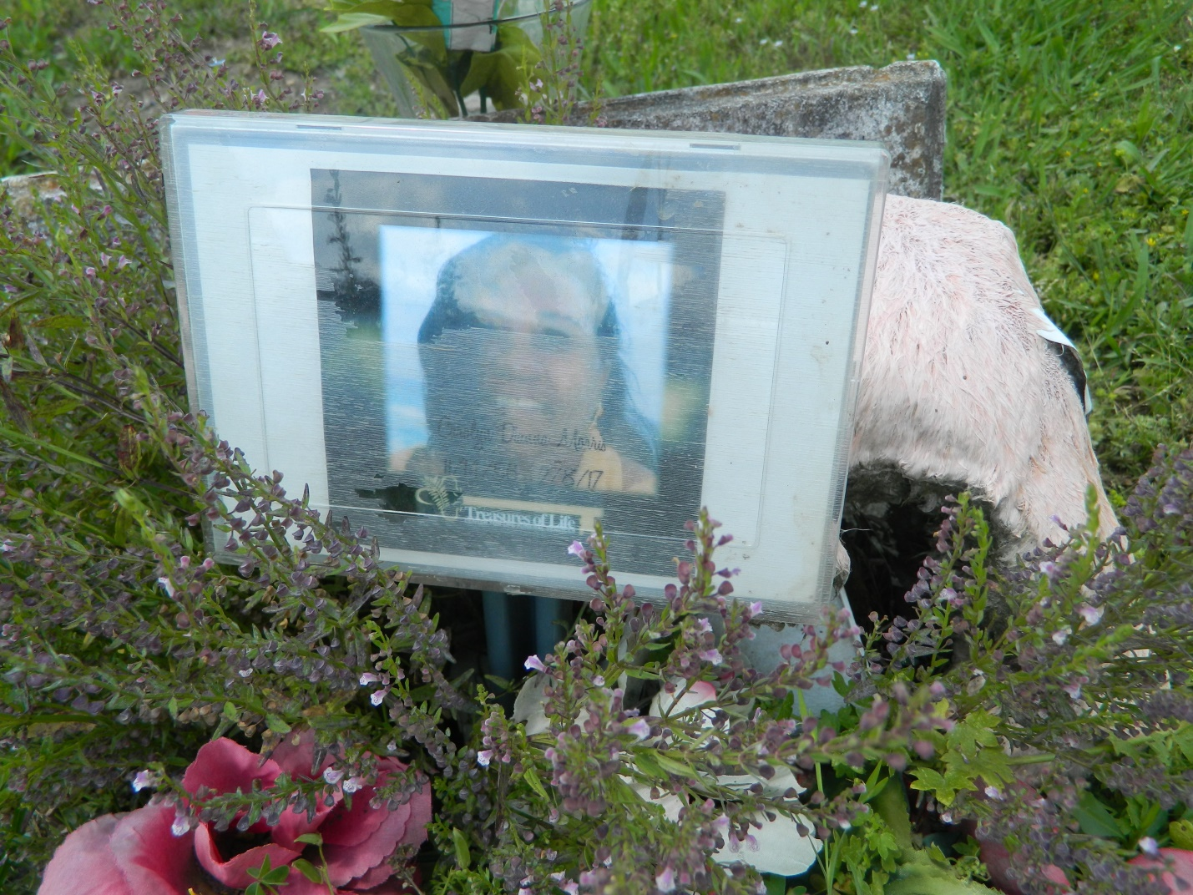

Carolyn Dianna Morris went on to be with her Lord and Savior Jesus Christ on Wednesday, February 8, 2017. She was born on November 14, 1956 to the late Ethelyn Poche and Melvin Morris Sr. Retired from Entergy, Dianna was the mother of Schwannie Morris, Derrick Morris Sr. (LaToya) and Dana Lewis. Sister of Jimmy Morris, Ralph Morris and the late Betty Morris Montgomery and Melvin "Butch" Morris, Jr. Grandmother of Tyree Lewis, Derrick Jr., Kylie, Kennedi Morris and Sayria Lane. She is also survived by a host of aunts, uncles and other relatives and friends. Relatives and friends of the family, also pastor, officers, members of Second African Baptist Church and St. John the Baptist Catholic Church in Edgard, La., and all neighboring churches, Second Ward High School, Edgard, La, and employees of Entergy, Inc. are all invited to attend a funeral service at 11:00am on Saturday, February 18, 2017 from Second African Baptist Church, 136 W 3rd Street, Edgard, La. 70049. Rev. C. Z. Mollaire, officiating. Visitation from 9:00am until service time. Interment Young Cemetery, Edgard, LA. Treasures of Life- Center for Life Funeral Services, 315 E Airline Hwy, Gramercy, La. 70052, have been entrusted with her final care. Please visit [treasurefunerals.com](http://treasurefunerals.com) to sign the online guestbook. "When someone you love becomes a memory, that memory becomes a TREASURE!"

**Times-Picayune, The (New Orleans, LA) - Thursday, February 16, 2017**

**Contributed by Jane Edson**