Ethel Mae (Shepperd) Morris

Abt. 1926 – July 3, 2001

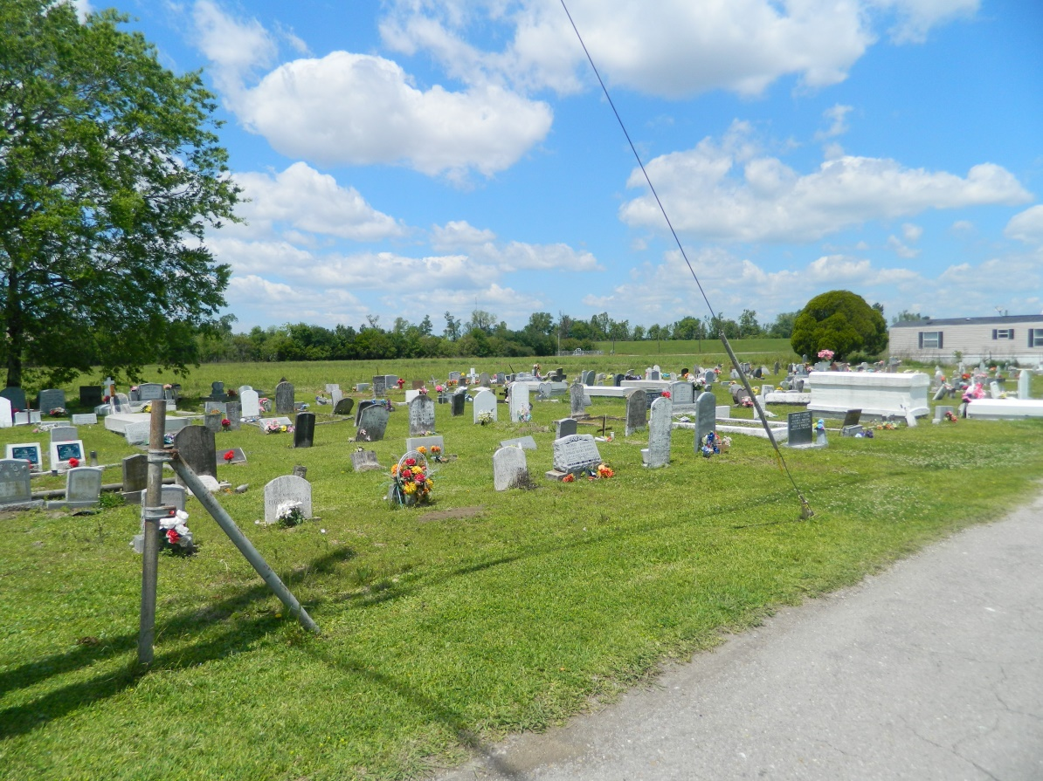

EDGARD - Ethel Mae Shepperd Morris, 75, a native and resident of Edgard, died July 3. She was the wife of the late Walter Morris and mother of Laura Aly, Beverly Williams, Gloria Stockman, Brenda Batiste, Dorothy Johnson and the late Dolores Morris. She was also the daughter of the late Victorian and Priscilla Gordon Shepperd and sister of Mercedes Fountain, Blanche Foucher and Ellau Shepperd and the late Hazel, Lawrence, Cleveland, Alex, Alice, Elouise, Fabolia, Elnora and Joyce Shepperd. She is also survived by nine grandchildren and two great-grandchildren. Services are today at 11 a.m. at Greater New St. Peter Baptist Church, Edgard, with interment at Young Cemetery, Edgard. Visitation starts at 9 a.m.

[**L'Observateur**](http://www.lobservateur.com)**, LaPlace, LA; July 07, 2001**