Hillary Pierce Sr.

January 22, 1903 – March 17, 1987

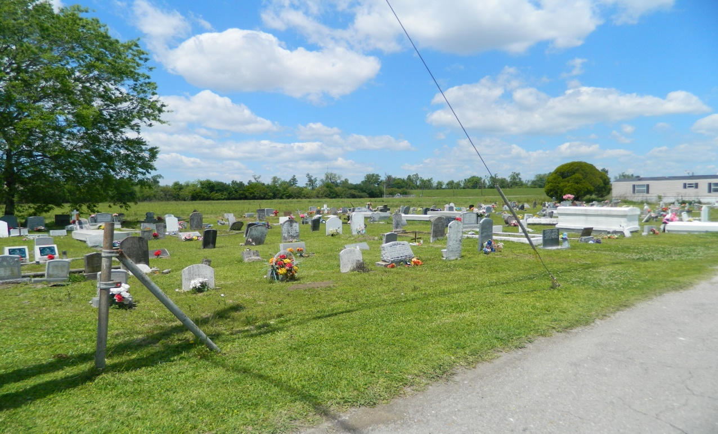

Mr. Hillary Pierce, Sr., on Tuesday, March 17, 1987 at Ochsner Foundation Hospital, husband of the late Mrs. Elvira Pierce; father of Mr. Hillary Pierce, Jr.; son of the late Mr. and Mrs. Joseph Pierce, Sr.; father-in-law of Mrs. Theresa Pierce; grandfather of Messrs. Hillary III, Steve and Danny Pierce, great-grandfather of Trina, Naytone, Danielle, Stephany, Lawana, Dana and Dannetta Pierce; brother of Messrs. Elijah and August Pierce, Mmes. Louise P. Poche and Cecile P. Alden; pre-deceased by 5 brothers and 2 sisters; brothers-in-law of Mrs. Alice Lewis; also survived by 3 grand-daughters-in-law, 4 brothers-in-law, 3 sisters-in-law, 3 step-sisters a host of nieces, nephews, cousins, other relatives and friends.

Relatives and friends, also pastors, officers and members of St. Joseph, Greater Providence, Little Zion and First African Baptist Churches and Phillip Memorial Methodist Church, members of the Golden Leaf Club, staff of Ochsner Foundation Hospital, Booker T. Washington Senior High School and New Orleans Public School Board, are invited to attend the wake and funeral eulogy services at St. Joseph Baptist Church, 7731 Olive Street Sunday, March 22, 1987 8 p.m. Dismissal Monday 10 a.m. Rev. C.J. Allen, officiating. Motorcade leaving church for Edgard, LA  
Interment Young Cemetery, Edgard, LA. Dorothy Lawless, 3825 Washington Avenue in charge. Viewing at church 7:30 p.m. Sunday.

**The Times-Picayune (New Orleans, Louisiana) Sunday, March 22, 1987, Page 39**