Joseph Pierce Jr.

* April 28, 1959

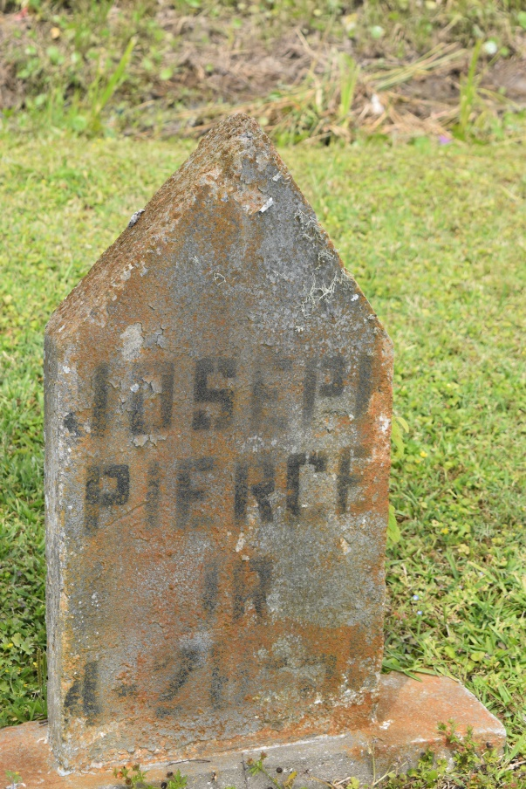

On Monday, April 27, 1959, at 5 o’clock a.m., Joseph Pierce Jr. (Toby), beloved husband of Mrs. Glen Pierce; foster father of Mrs. Lela Mae Royal and Charles Miller; brother of Elijah, Hillary Sr., Paul, Milton, Henry and Augustus Pierce, Madames Cecile Pierce Allen, Louise Poche and Agnelia Hitchens; nephew of Ambrose Ferdinand, Rebecca Alexander, William and Hezekiah Pierce; deceased also survived by a host of nieces, nephews, cousins and friends; a native of Wallace, La., and a resident of this city for many years.

Relatives and friends of the family, also pastor, officers and members of Progressive Baptist church, Loving Four Tabernacle, Little Zion, St. Joseph, First African Baptist churches, Philip Memorial Methodist church, all of New Orleans, La., the Second New Guide Baptist church of Metairie, La., Providence Baptist church of Kenner, La., New St. Peter Baptist church of Edgard, La., and Local Union NO. 854 I.L.A., are respectfully invited to attend the wake on Friday night, May 1, 1959, at Alexander and Elum Undertaking Company, 1222 South Claiborne avenue.  
Remains will be forward via motorcade on Saturday, May 2, 1959, at 9:30 a.m. to Edgard, La., for funeral services at new St. Peter Baptist church, Rev. J.J. Harper officiating assisted by Rev. C.J. Allen.  Interment in Young’s cemetery. Alexander and Elum Undertaking company, Inc., in charge.

**The Times-Picayune (New Orleans, Louisiana) Friday, May 1, 1959, Page 2**