Orita (Gordon) Poche

July 25, 1909 – December 14, 2002

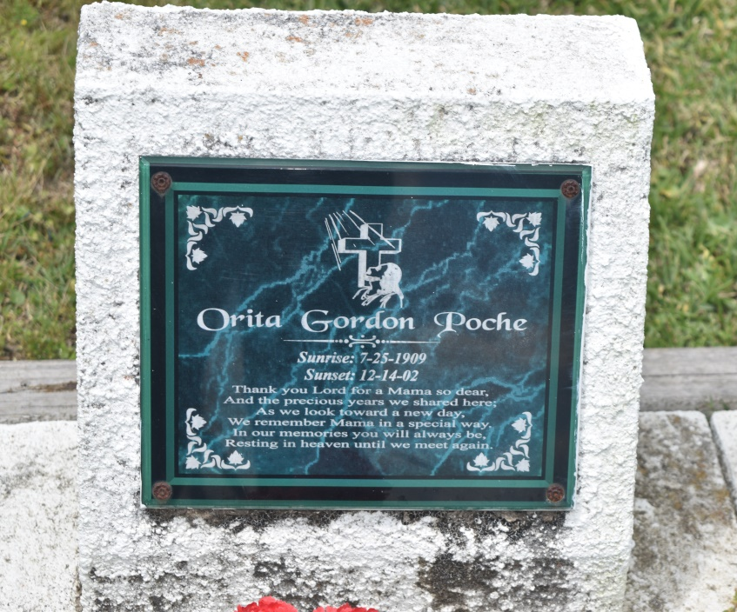

Orita G. Johnson Poche' entered into eternal life at her residence on Saturday, December 14, 2002 at 7:30 A.M. Loving wife of the late Herman Johnson, Sr. by first marriage and the late Paul Poche', Sr. by second marriage. Loving mother of Herman Johnson, Kermath and Sterling Poche', Dorothy J. Brantley, Nita P. Champagne, Rita P. Richards, and the late Melvin Johnson, Stanford and Paul Poche' Jr. Daughter of the late Morel and Charlotte Batencourt Gordon. Sister of Orena G. Herbert and Helmon Gordon. Mother in law of Geneva Johnson, Glenda, Debroah, and Carolyn Poche', Gary Champagne, and Alton Richards. Sister in law of Alma and Jackie Gordon, Bailey and Louise Poche', and Julia Crockett. Devoted friend of Beatrice Armstrong. Also survived by 39 grandchildren, 52 great grandchildren, 21 great great grandchildren and a host of nieces, nephews, cousins, other relatives and friends. Age 93 years. A native of Edgard, LA. and a resident of Marrero, LA. for the past 60 years.  
  
Relatives and friends also pastors, officers, and members of Morning Star B.C. and neighboring churches are invited to attend the funeral service. From Morning Star B.C., 1000 Cross St., Marrero, LA. on Friday, December 20, 2002 at 10:00 A.M. Visitation will begin at 8:30A.M. until service time at the church. Rev. Thomas J. Brown officiating. (NO WAKE). Visitation from DAVIS MORTUARY SERVICE, 6820 Westbank Expressway, Marrero, LA. on Thursday, December 19, 2002 from 6:00P.M. until 8:00P.M. Interment: Young Cemetery-Vacherie, LA.  
  
Arrangements by Davis Mortuary Service, 230 Monroe St., Gretna, LA.

**Times-Picayune, The (New Orleans, LA) - Thursday, December 19, 2002**

**Contributed by Jane Edson**