Oscar Simon

August 26, 1921 – August 12, 2003

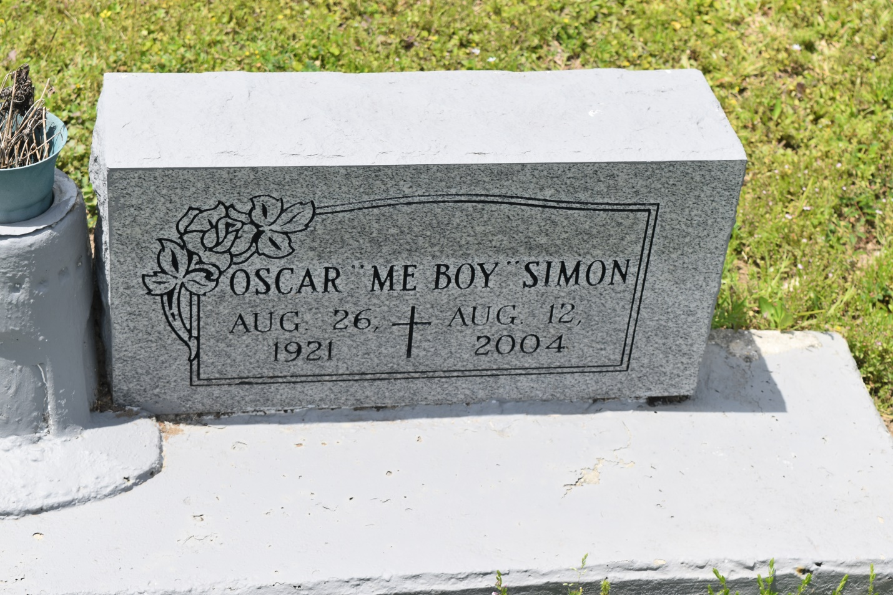

Oscar "Me Boy" Simon, a retired laborer, died Aug. 12 at Lindy Boggs Medical Center. He was 82. Mr. Simon was born in Edgard and lived in New Orleans for the past nine years. Survivors include a son, Melvin Simon Sr.; a brother, Lester Simon of Edgard; a sister, Mary Williams of New Orleans; three grandchildren; and two great-grandchildren. A funeral will be held Saturday at 10 a.m. at Shiloh Fellowship Church, 2441 N. Claiborne Ave. Visitation will begin at 9 a.m. Burial will be in Young Cemetery, Edgard. D.W. Rhodes Funeral Home is in charge of arrangements.

**Times-Picayune, The (New Orleans, LA) - Thursday, August 19, 2004**

**Contributed by Jane Edson**