Ceola (Martin) Temple

June 5, 1926 – August 14, 2006

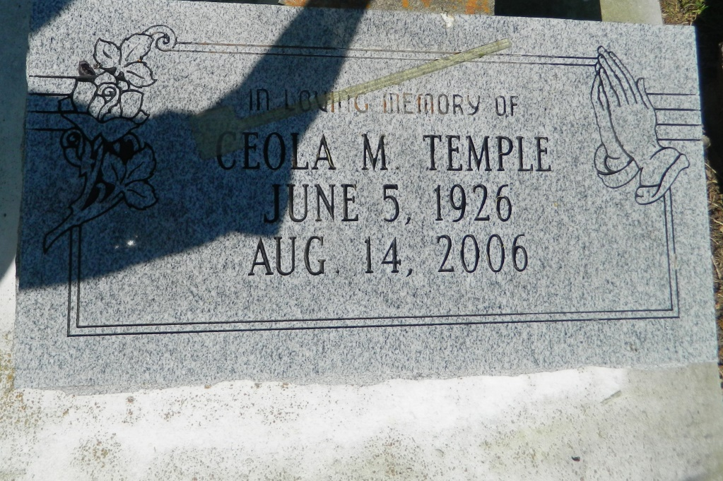

Ceola M. Temple on Monday, August 14, 2006 at River Parishes Hospital, LaPlace, LA. Daughter of the late Eddie and Florestine B. Martin, Sr. Wife of Charles Temple, Sr. Mother of Charles Temple, Jr., Herbert Temple, Annie T. Ingram, Shirley T. Wilson, Elaine T. Anderson, Judith, Calvin and Michael Temple. Sister of Margaret Williams, Mable Edwards, Martha Domino, Mary Charles, the late Agnes Temple, Evelina Coleman and Eddie Martin, Jr. Also survived by 23 grandchildren, 17 great-grandchildren, 4 daughters-in-law, 4 sons-in-law, a host of nieces, nephews, other relatives and friends. Age 80 years. A native of St. James, LA and a resident of Ama, LA.  
  
Relatives and friends of the family; also pastors, officers and members of New JerusaleM, Antioch, Mt. Airy and Providence #2 Baptist Churches and all neighboring churches; employees of Monsanto, Cytex, LA Department of Transportation and Louis Armstrong New Orleans International Airport are invited to attend the Funeral Service at New Jerusalem Baptist Church, 152 E. 6th Street, Edgard, LA on Saturday, August 19, 2006 at 11:00 a.m. Rev. Joseph Johnson, Jr., Pastor - officiating. Interment Jerusalem Cemetery, Edgard, LA. Visitation at the above named Church from 9:00 a.m. until service time.  
  
SERVICED BY ROBOTTOM

**Times-Picayune, The (New Orleans, LA) - Friday, August 18, 2006**

**Contributed by Jane Edson**