Jaunita Valentine

September 25, 1943 – October 6, 2009

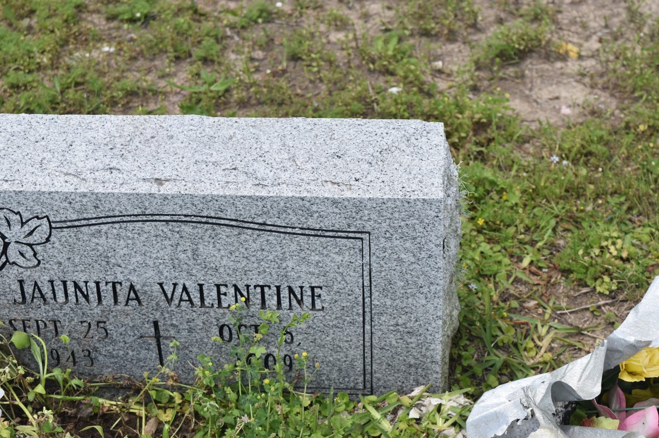

Jaunita Valentine on Tuesday, October 6, 2009 at St. James Parish Hospital, Lutcher, LA, departed this life at the age of 65 years. Daughter of the alte Azerius and Alberta Valentine. Mother of Valerie Lewis Howard, Trechell Lewis Toney, Kenneth, Reginald, and Rodney Lewis. Sister of Dorothy Milton, Shelton, Jacob and George Valentine. Also survived by 16 grandchildren, 1 great-grandchild, 1 uncle, 1 devoted cousin, Ernestine Traylor and friends. Preceded in death by siblings: Shirley Coleman, Azerius Jr. and Augufur Valentine.  
  
Relatives and friends of the family, also pastors, officers and members of the Greater New St. Peter B.C. and neighboring churches are invited to attend the Funeral Services on Saturday, October 10, 2009 at 11:00 a.m. Rev. Vernon Alexander, Sr., Pastor, officiating. Interment Young Cemetery, Edgard, LA. Visitation will begin at 9:00 a.m.  
  
The Baloney Funeral Home, LLC, 399 Earl Baloney Dr., Garyville, LA 70051, Information: (985) 535-2540 in Charge of Arrangements.

**Times-Picayune, The (New Orleans, LA) - Friday, October 9, 2009**

**Contributed by Jane Edson**