Willis Young Jr.

May 28, 1939 – July 24, 2003

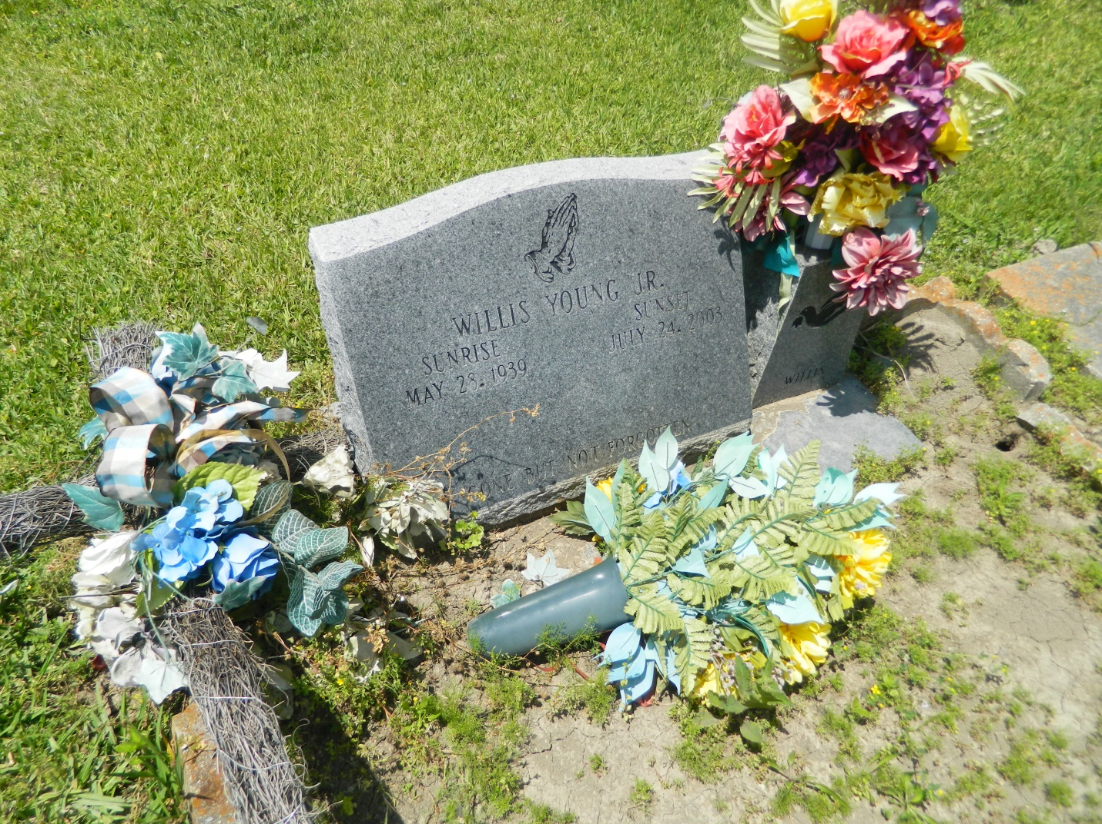

Willis "Sissy" Young Jr., a retired painter for Avondale shipyards, died July 24 of cancer at Metropolitan Hospice. He was 64. Mr. Young was a lifelong resident of Edgard. Survivors include his wife, Eula Turley Young; two sons, Staffon Turley and Mario Young; a daughter, Trina Y. Lawrence; four sisters, Shirley Mason and Lutha Mason of Reserve, Irma Roussell and Lillie Johnson; a brother, Alfred Young; eight grandchildren; and three great-grandchildren. He was the guardian of Janell Roussell. A funeral was held Monday at Greater New St. Peter Baptist Church. Burial was in Young Cemetery in Edgard. The Baloney Funeral Home was in charge of the arrangements.

**Times-Picayune, The (New Orleans, LA) - Tuesday, July 29, 2003**

**Contributed by Jane Edson**