Warren Albert Sr.
June 20, 1940 – March 9, 2002

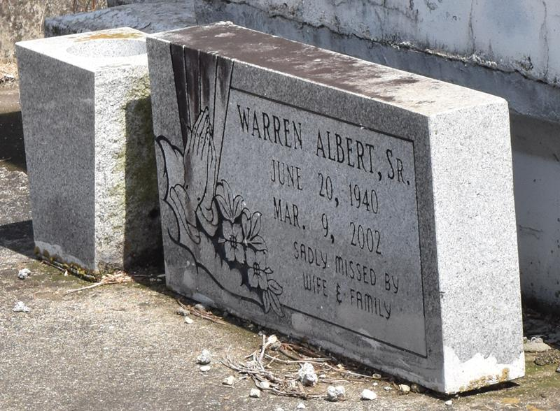

PAULINA - Warren Albert Sr., 61, a native and resident of Lutcher, died March 9. He was the husband of Sarah Moore Albert and father of Alma Walter, Catherine Rainey, Terry and Claudia Albert, Leashonda and Helen Adams and Warren Jr., Joseph and Kerry Albert. He was the son of the late Johnny Jr. and Georgina Johnson Albert and brother of Lillian Landry, Helen Smith, Barbara, Joseph, Johnny III, Junius and Clarence Albert and the late Eva Mae Michael and Lawrence Albert. He is also survived by 15 grandchildren and five great-grandchildren.
Services are today at 11 a.m. at Evergreen Baptist Church, Paulina, with interment at Antioch Cemetery, Paulina. Visitation starts at 9:30 a.m.

L'Observateur, La Place, Louisiana
Monday, March 18, 2002

