Debra A. (Selders) Barney
April 8, 1954 – June 5, 2010

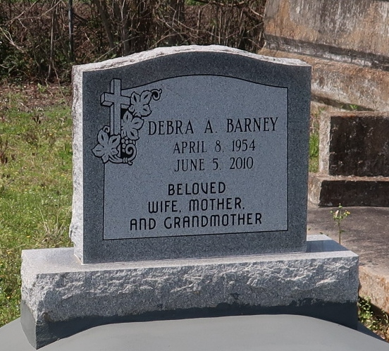

A native of Kenner and resident of Paulina, Gramercy and Texas, she died at her home in Cypress, Texas, Saturday, June 5, 2010, at 9:35 a.m. She was 56.
Visiting at Greater Evergreen Baptist Church, La. 44, Paulina, on Saturday, June 12, from 9:30 a.m. until religious service at 11 a.m., conducted by the Rev. Nolan Albert. Interment in Antioch Baptist Church Cemetery, Paulina.
Survived by her husband, Gary James Barney; mother, Margaret Crain Selders; daughters, Lashonda and LaTonya Lewis; two sons, Tabyron and Michael Lewis Jr. and wife Danielle; stepdaughter and husband, Keri and Aaron Bovie; stepson and wife, Kylan and Juanika Barney; brothers, Bobbie and Gerald Selders; sisters, Barbara and husband Edward Alexander, Aline and husband Fred Bellard, Betty S. Alexander, Margarite S. Blair, Deloris S. Taylor, and the late Cheryl Lyn, Emmitt and Woodrow Selders Jr.; mother-in-law, Dorothy Barney; sister-in-law, Barbara B. LaGrange; 10 grandchildren, three great-grandchildren, aunts, uncles, nieces, nephews, cousins, other relatives and friends.
Preceded in death by her father, Woodrow Selders Sr.; daughter, Cheryl Lyn Selders; two brothers, Emmitt and Woodrow Selders Jr.;
and father-in-law, James Barney.
Arrangements by Brazier-Watson Funeral Home, Donaldsonville.

TheAdvocate.com
June 11, 2010

