Darryle Bolton
October 11, 1951 – April 25, 2027

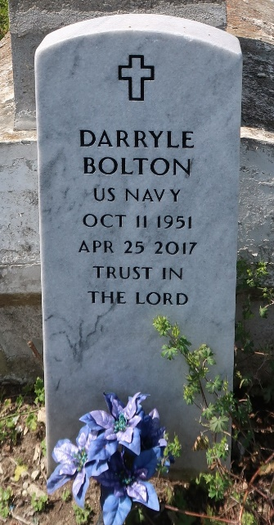

U.S., Public Records Index, 1950-1993, Volume 1

Name Darryle Bolton Sr
Birth Date Oct 1951
Residence Date 1993
Address 1622 Caton CT
Residence New Orleans, LA
Postal Code 70122-2447
Second Residence Date 1993
Second Address 8604 Apricot St
Second Residence New Orleans, LA
Second Postal Code 70118-2237
**

U.S., Phone and Address Directories, 1993-2002

Name Darryle Bolton
Residence Years 2002
Address 3428 Elysian Fields Ave
Residence Place New Orleans, Louisiana, USA
Zip Code 70122-4504
Phone Number xxx
Spouse Diane Bolton

