Harry Bourgeois
February 15, 1926 – January 15, 2005

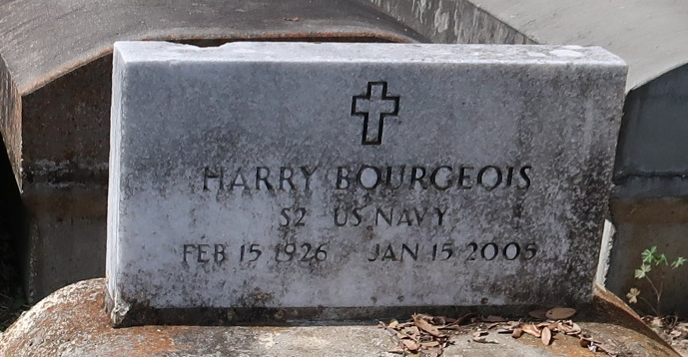

A resident of Reserve and a retired automobile mechanic and retired school bus driver, he died Saturday, Jan. 15, 2005, at 3:28 p.m. at River Parishes Hospital, LaPlace. He was 78 and a native of Paulina.
Visiting at Evergreen Baptist Church, 3762 La. 44, Paulina, from 9:30 a.m. Wednesday, Jan. 19, until religious service at 11 a.m., with the Rev. Sonya Lars officiating. Interment in Antioch Cemetery, Paulina.
He is survived by his former wife, Anna Lee Bourgeois, and to that union three daughters and a son were born, Patricia Bourgeois, Janice Bourgeois Singleton, Aleta Bourgeois Doherty and Murray Bourgeois. He is also the father of Betty Bourgeois-Potts, Sandra Clark, Shenell Thomas and Daphne Woodley. He is also survived by three sisters, Ida Russell, Jersey Henry and Shirley Fluence; 10 grandchildren, four great-grandchildren, a daughter-in-law and numerous sons-in-law, nieces, nephews, cousins, brothers-in-law, sisters-in-law, other relatives and friends. He was preceded in death by his parents, Joseph Bourgeois and Elnora Price Bourgeois. He was a member of Lutcher Chapel United Methodist Church.
Brazier-Watson Funeral Home, Donaldsonville, is in charge of arrangements.

Advocate, The (Baton Rouge, Louisiana)
Tuesday, January 18, 2005

