Fayona V. (Marcell) Brown
June 20, 1960 – February 15, 2019

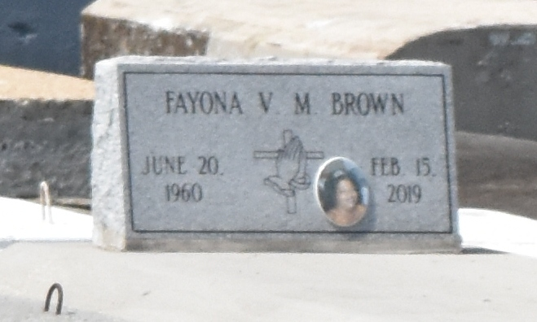

A native of Paulina and a resident of Lutcher. Fayona passed away in New Orleans at the age of 58 [2/15/2019].
Survived by her husband, Allen Brown. Her daughters: Allyneika and Allyneisha Brown and her son, Allen Brown. Her sister: Sonja Marcell. Brothers: Michael (Jennifer) Marcell, Dwayne Marcell, and fiancé, Darlene Mayo, numerous nieces, nephews, cousins, other relatives and friends.
Preceded in death by her parents: Freeman Marcell, Sr. and Georgia Noel Marcell. Her brother, Freeman Marcell, Jr.
Brazier-Watson Funeral Home in charge of arrangements

The Advocate, Baton Rouge, Louisiana
Feb. 20-22, 2019

