Roseanna (Williams) Burden
July 15, 1922 – May 29, 2009

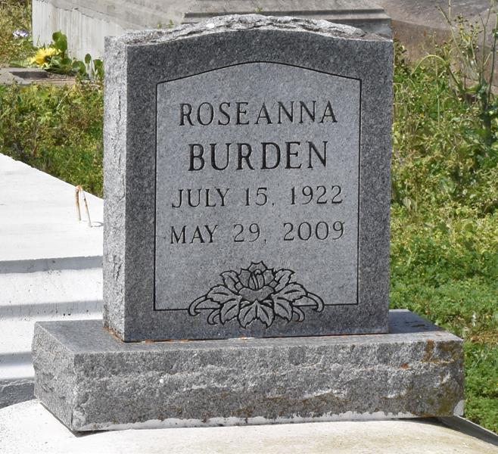

A native and resident of Lutcher, she died at 2:15 a.m. Friday, May 29, 2009, at St. James Parish Hospital, Lutcher. She was 86.
Visiting at King David Baptist Church, Lutcher, on Friday, June 5, from 9:30 a.m. until religious service at 11 a.m. Interment in Antioch Cemetery, Paulina.
Survived by her brother, Joseph Williams; nieces and nephews, including Roselind Langford and Adam Cooper; cousins, other relatives and friends. Preceded in death by her parents, Sullivan Williams and Theresa Shade Williams; husband, James Burden; two sons, Ronald and Alex Burden;
two sisters, Shirley Traveler Weber and Annabelle Williams; and two brothers, Adam Cooper Sr. and August Williams.
Arrangements by Brazier-Watson Funeral Home.

The Advocate, Baton Rouge, Louisiana
Thursday, June 4, 2009

