John Wesley Burns, Jr.
November 16, 1956 – May 3/2021

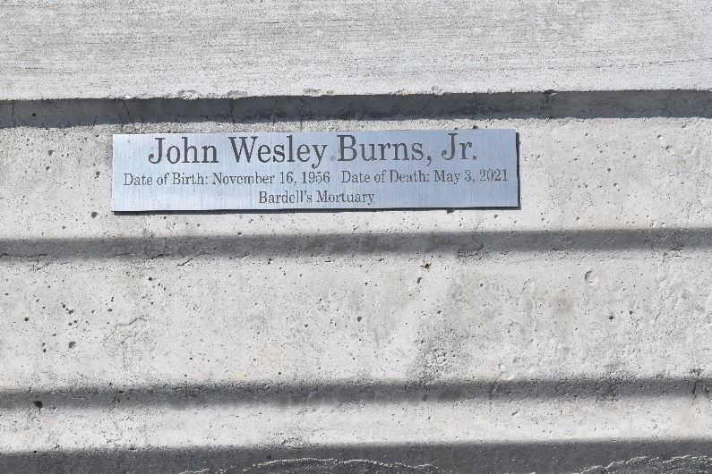

No further information found at this time.

